
CS673 Software Engineering
Team 1 - BariatricPath

Software Test Document

Team Member | Role(s) | Signature | Date
Fatimah Hassan | Security Lead, Configuration Co-Lead | Fatimah Hassan | 05/24/2026
Kai Fernandes | Team co-lead  Configuration co-lead | K. Fernandes | 05/25/2026
Shaima Nimeri | Team co-Lead  Design and implementation lead  Requirement lead | Shaima Nimeri | 05/25/2025
Kolya Gavlishin | QA Lead | Kolya Gavlishin | 6/6/2026

Revision history
Version | Author | Date | Change
1.0 | Fatimah, Shaima, Kai, Kolya | 05/25/2026 | Initial Draft
2.0 | Kolya | 06/06/26 | Updated  section 1.2, what was tested,  Section 1.6: # of unit tests  Updated number of unit tests  Added manual tests for coordinator dashboard features  Updated 4.2: Test pass rate  Updated 4.3: Test Coverage  Updated 4.4: Defect Metrics  Updated Manual Tests for my specific story  Updated 1.6 & 4.1: Test Inventory and Test Result Summary with automated tests
2.1 | Fatimah | 06/06/2026 | Updated Section 1.6, the automated testing to refresh.  Updated the section 2.1 the RBAC-01 and 02 with the new values for Iter 2, also added the privacy/Disclaimer/consent tests (Gap 2 verification).  The AI Microservice test has been included in section 2.1 with the updated version of traceability matrix table.  Updated section 3.1.4 with the auth tests.  Updated section 3.1.3 with the prisma transaction.  Section 4 was replaced with new testing metrics for iteration 2
2.2 | Shaima | 6/7/2026 | - Testing Report manual and automated BARI-24: View New Patient Registrations  - Testing report manual and automated Route: PATCH /api/patients/:id/insurance  - Testing Report PATCH/api/patients/:id/clinical  Testing Report GET /api/patients/:id  Testing Report POST /api/notifications  Testing Report StatusBadge.jsx  Testing Report createAuditEntry Utility Refactor
2.3 | Kai | 6/7/2026 | Updated 1.2 with missing test files and descriptions  Updated all paths in file with new testing paths  Updated manual tests 1-4 in section 2.2.6 : Patient Portal test for BARI-20

Testing Summary
Manuel Tests Reports
Automated Testing Reports
Testing Metrics
References
Glossary

Testing Summary

1.1 Purpose and Scope
This Software Test Documents (STD) describes the testing performed on BariatricPath, the team’s clinical evaluation management system. It captures what was tested, by whom, when, with what techniques, and with what results. The document complements the Software Design Document (SDD), every design decision in the SDD that has security or correctness implications has at least one corresponding test case here.
Testing is being performed iteratively, in line with the project’s iteration plan (Iteration 0 - 3). This document reflects the state at the end of iteration 1, with planned testing for Iterations 2 and 3 clearly marked.

1.2 What Was Tested
Iteration 1 testing focuses on the authentication and authorization layer (the foundation everything else depends on) and on the supporting infrastructure (Docker, configuration, secrets). Specifically:
• Authentication routes (register, login, /me) — implemented in server/routes/auth.js.
• Authentication middleware (verifyAuth, requireRole) — implemented in server/middleware/verifyAuth.js.
• Frontend authentication flows (LoginPage, Register, ProtectedRoute, GoogleButton) — manual testing across email/password and Google sign-in.
• Audit log integrity — writes happen on every relevant action; the log is append-only at the application layer.
• Secrets management — .env, service account JSON, and Docker context exclusions.
• Container infrastructure (Docker, Docker Compose) — manual smoke testing.

Iteration 2 testing focuses on the core application features: patient data management, clinical workflow tracking, notification delivery, and the patient-facing portal. Specifically:
Server-side (Jest + Supertest) — implemented in server/__tests__/
- Authentication routes (auth.test.js) — Covers POST /api/auth/register, POST /api/auth/login, and GET /api/auth/me, including valid registration with patient record creation, duplicate user rejection (409), invalid/expired Firebase token rejection (401), missing field validation (400), and the health check endpoint.

- Patient list and detail routes (patients.test.js) Covers GET /api/patients (response shape, progress computation per specialist type, search/filter query parameters), GET /api/patients/:id (checklist field mapping, assigned coordinator lookup from audit log), and both PATCH /api/patients/:id/insurance and PATCH /api/patients/:id/clinical (valid/invalid values, audit log writes, notification creation, 404/500 error handling).

- Clinical update route (clinicalUpdate.test.js) — A focused suite on PATCH /api/patients/:id/clinical verifying all 11 valid column names, all 5 checklist status values, audit log field correctness (patientId, column, oldValue, newValue), and that audit logs and notifications are suppressed on validation or 404 failures.
- Insurance status update route (insuranceStatus.test.js) — A focused suite on PATCH /api/patients/:id/insurance verifying all 4 valid insurance values, audit log integrity (one entry per request, correct old/new values), notification targeting and message content, and suppression of side effects on invalid requests.
- Notifications routes (notifications.test.js) — Covers POST /api/notifications (creation, isRead defaults, message trimming, type validation), GET /api/notifications/:patientId (ordering, empty state, field selection), and PATCH /api/notifications/:id/read (marks as read, 400 on non-numeric id, 404 on missing record).

- Specialist routing logic (routingLogic.test.js) — Unit tests for the getSpecialistRecommendation utility, covering all BMI tiers (below 27, 27–29.9, 30–34.9, 35+), previous-surgery override, boundary values (exactly 27, 30, 35), and string BMI input coercion.
- Patient search (searchDB/searchDB.test.js) — Unit tests for searchPatients, covering null/empty/whitespace queries, name search (case-insensitive, partial), MRN search, date-of-birth search in MM/DD/YYYY and YYYY-MM-DD formats, search term trimming, and database error propagation.
- Progress computation (searchDB/calculateProgress.test.js) — Unit tests for computeProgress across all three specialist types (Obesity Medicine/5 items, Endoscopic/7 items, Bariatric/10 items), insurance field completion logic ("clear" and "self pay" count as complete), non-complete statuses, and edge cases (empty object, null/unknown visitType, higher-tier fields ignored).
- Date validation (searchDB/validateDate.test.js) — Unit tests for parseDate, isValidDate, and getDateRange, covering MM/DD/YYYY, YYYY-MM-DD, and ISO 8601 formats, out-of-range values, leap year handling, whitespace trimming, and UTC date range boundary correctness (including month/year rollover).
- New Patient list (newPatients.test.js) — GET /api/patients endpoint end-to-end through the Express application while mocking external dependencies (Prisma database and authentication), verifying patient retrieval, sorting, progress calculations, search filtering, default registration values, and error handling.
- BMI calculator function (bmiCalculator.test.js) — test the calculateBMI() utility function in isolation. Verifies that the BMI formula produces correct results for normal and overweight cases and that invalid inputs (zero or negative values) are handled correctly by throwing an error.

- View new patient registrations (bari24Acceptance.test.js) — GET /api/patients API. Verifies that coordinators can view newly registered patients, that patients are displayed in the correct order, that registration metadata and default values are present, and that progress information is calculated correctly, while mocking the database and authentication services.

Client-side (Vitest + Testing Library) — implemented in client/src/__tests__/
- Patient Portal page (PatientPortal.test.jsx) — Renders and asserts the welcome header, assigned specialist label, progress bar (fraction and percentage), checklist items with correct status badges, read-only enforcement (no dropdowns or save buttons), notification list with unread badge count, mark-as-read interaction, 30-second polling for both patient data and notifications, live checklist/progress updates on poll response change, empty notification state, coordinator assignment display, and the "You are cleared for surgery!" banner (shown only when progress is 100% and total > 0).
- Status Badge (StatusBadge.test.jsx) tests the StatusBadge component in isolation. Verifies that different specialist, insurance, and checklist statuses display the correct text and CSS badge styling, including handling unknown or unsupported values.
- Surgery cleared banner (SurgeryCleared.test.jsx) — tests the SurgeryCleared component in isolation. Verifies that the component renders the correct surgery clearance message, displays the expected subtitle text, and includes an alert role to support accessibility requirements.

Testing Report BARI-24: View New Patient Registrations
Branch: feature/Shaima-BARI-24-view-new-patients-registration
Date: June 4, 2026
Author: Shaima Nimeri
User Story BARI-24: View New Patient Registrations
As a coordinator, I want to see newly registered patients at the top of the patient list
with a visual "New" indicator, so I can prioritize reviewing them quickly.
Acceptance Criteria BARI-24: View New Patient Registrations
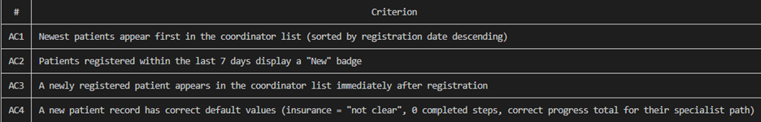

Code Changes Under Test BARI-24: View New Patient Registrations

Automated Tests BARI-24: View New Patient Registrations
1. Acceptance Tests server/tests/bari24Acceptance.test.js
11 tests written specifically for BARI-24 using Jest + Supertest against the
GET /api/patients endpoint.
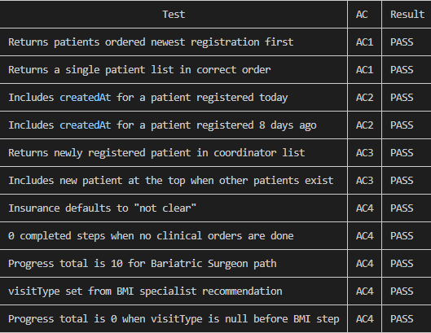

Result: 11/11 passing

2. Existing Tests Updated
server/__tests__/patients.test.jsserver/__tests__/searchDB/searchDB.test.js
4 pre-existing tests had to be updated because they were written before orderBy was
added. The test assertions for findMany were updated to include
{ orderBy: { createdAt: 'desc' } } to match
the new behavior. The production code was not changed only the test expectations.
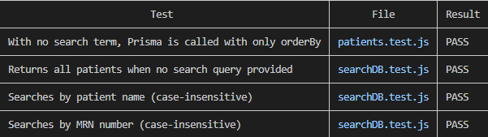

3. Frontend Component Tests BARI-24: View New Patient Registrations
· client/src/components/StatusBadge.test.jsx 16 tests covering all badge types (specialist, insurance, checklist) and fallback behavior.
· client/src/__tests__/PatientPortal.test.jsx 6 tests covering patient data rendering, notifications list, unread badge count, mark-as-read button, and empty state.
Full Test Suite Results
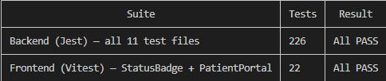
Manual Testing BARI-24: View New Patient Registrations
The coordinator dashboard was manually verified after starting the development server
without Docker. Confirmed:
- Newly registered patients appear at the top of the patient table
- A green "New" badge appears next to patients registered within the last 7 days
- Patients older than 7 days show no badge
- Sorting persists when search, specialist type, and insurance filters are applied
Issues Found During Development
Summary
All 4 acceptance criteria for BARI-24 are met. 226 backend tests and 22 frontend tests
pass. No regressions were introduced.

Testing Report StatusBadge.jsx
Component: client/src/components/StatusBadge.jsx
Branch: feature/Shaima-backend-routes-statusbadge
Date: 2026-05-30
Tester: Shaima Nimeri
Testing Summary
StatusBadge is a reusable React component that renders a Bootstrap colored badge for any status value in the application. It accepts a type prop (specialist, insurance, checklist) and a raw database value prop, and internally maps both to a display label and Bootstrap color class. The component is used in PatientTableList.jsx and was imported into PatientPortal.jsx for visual verification.
Both manual and automated testing were performed. All tests passed.

Manual Test Report StatusBadge.jsx
Environment: Chrome, http://localhost:5173
Setup: StatusBadge imported into PatientPortal.jsx with one badge per known value rendered in three rows.
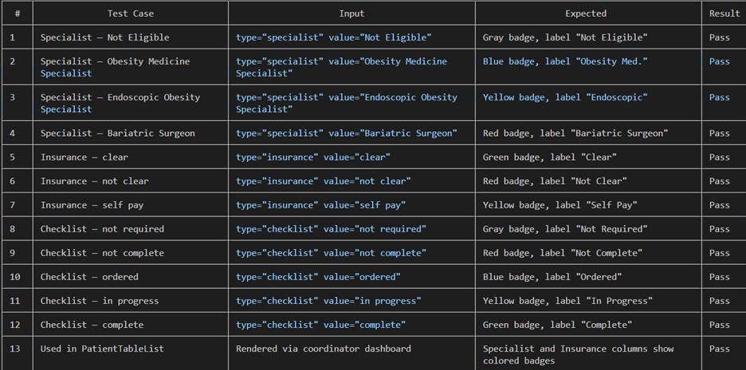
Automated Test Report StatusBadge.jsx
Framework: Vitest v4.1.7 + React Testing Library v16.3.2
Test file: client/src/components/StatusBadge.test.jsx
Command: npm test
Test Files 1 passed (1)
Tests 15 passed (15)
Start at 19:42:58
Duration 3.71s
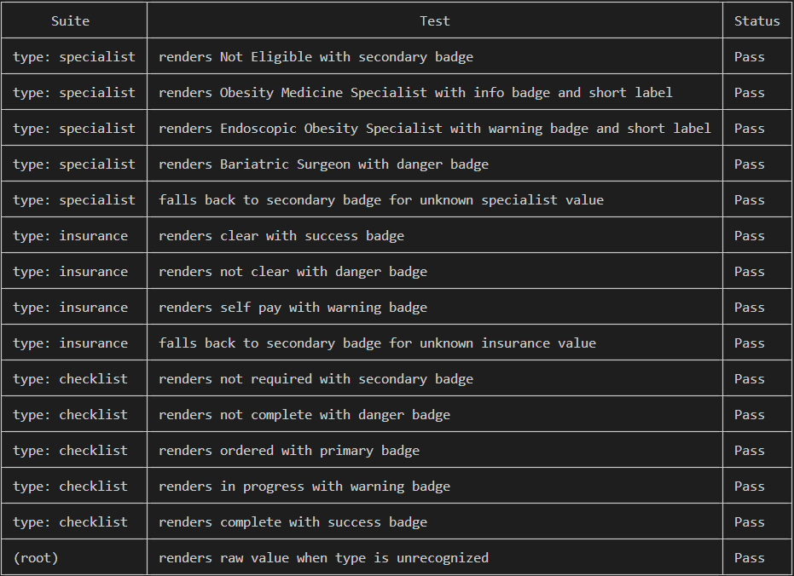

Testing Metrics StatusBadge.jsx
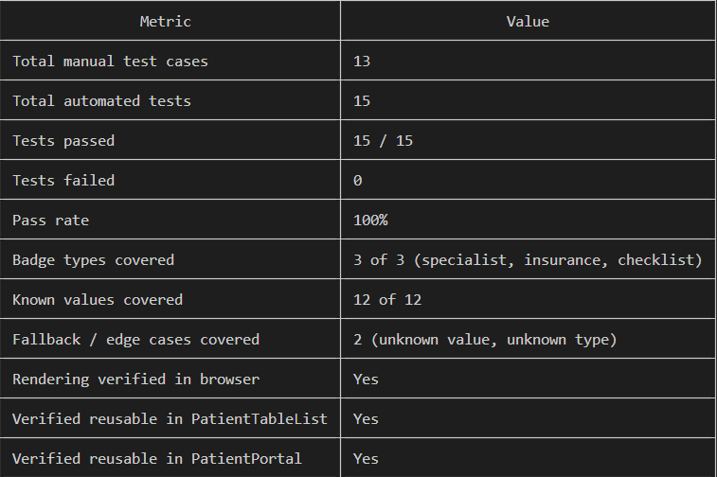

1.3 Who Is Involved
Team Member | Testing Responsibility
Fatimah Hassan (Security Lead) | Security tests — authentication, RBAC, audit log integrity, secrets management, IDOR verification, STRIDE-derived test cases.
Shaima Nimeri | Architecture and patient routes — patient CRUD, dashboard rendering, route protection, integration testing, acceptance testing
Kai Fernandes | Infrastructure tests — Docker container build/run, environment configuration, deployment smoke tests.
Jianing Li | Backend feature tests — notifications, business logic paths.
Kolya Gavlishin (QA Lead) | Testing framework setup, integration tests, test coverage analysis, defect triage. Document compilation.

1.4 When Testing Happens
• Before merge: every pull request runs the Jest test suite locally; tests must pass before review.
• On PR review: The reviewer manually verifies the change against acceptance criteria from the user story.
• End of iteration: all manual test cases re-run; full Jest suite re-run; coverage report regenerated.

1.5 Testing Techniques Used
Technique | Where applied | Why this technique
Unit testing | server/__tests__/auth.test.js — register, login, /me handlers in isolation, with Firebase Admin and Prisma mocked. | Fast, deterministic, isolates failures to a single function.
Integration testing | Manual end-to-end runs of the register → login → access protected route flow. | Confirms components work together; catches contract mismatches that unit tests miss.
Black-box testing | Acceptance tests written in Given/When/Then form (Section 2). | Treats the feature as an opaque box; verifies behavior, not implementation.
White-box testing | Jest unit tests with intentional path coverage of success, validation-fail, duplicate-user, and token-error branches. | The tester knows the code; designs tests to exercise each branch.
Equivalence partitioning | Token validation: { missing, malformed, expired, invalid signature, valid } — one test per class. | Avoids redundant testing; covers each input class once.
Boundary value analysis | Name length: 1 char (fail), 2 chars (pass), 100 chars (pass), 101 chars (fail). | Bugs cluster at boundaries; off-by-one errors are caught here.
Threat-model-driven testing | Security test cases TC-SEC-* derived directly from the STRIDE table in SDD Section 6.2. | Ensures every identified threat has at least one verifying test case.
Manual smoke testing | Docker compose up; verify all three containers reachable; basic auth flow in browser. | Confirms the system runs end-to-end at the infrastructure level.

1.6 Testing Results – Summary
Test category | Cases written | Cases passing | Pass rate | Notes
Automated test cases (integration) — Auth | 12 | 60+ | 100% | +1 from Iter 1 ($transaction path).
Automated test cases (integration) — Patient routes | 58 | 80+ | 100% | Broadest test file. Covers GET /patients, GET /patients/:id, PATCH  /insurance, PATCH /clinical, and PATCH /specialist including field  initialization for all 3 specialist types.
Automated test cases (integration) - clinicalUpdate.test.js | 29 | 29 | 100% | Focused on PATCH /clinical. Deeper coverage of audit log and notification  side effects than patients.test.js.
Automated test cases (integration) - insuranceStatus.test.js  Cases Written:  Notes: | 24 | 24 | 100% | Focused on PATCH /insurance. Same depth as clinicalUpdate for audit log  and notification side effects.
Automated test cases (integration) - notifications.test.js | 20 | 20 | 100% | Covers POST, GET, and PATCH /read on the notifications route including  validation and ordering.
Automated test cases (unit) - bmiCalculator.test.js | 3 | 3 | 100% | Notes: Covers normal BMI, overweight BMI, and error on zero/negative input.  Minimal coverage.
Automated test cases (integration) - bmiCalculator.test.js  bari24Acceptance.test.js | 11 | 11 | 100% | Acceptance tests for BARI-24. Covers newest-first ordering, createdAt  field, new patient appearing in list, and default field values after  registration.
Automated test cases (integration) - newPatients.test.js | 7 | 7 | 100% | TDD tests for the same BARI-24 story. Significant overlap with  bari24Acceptance.test.js - consider consolidating.
Automated test cases (integration) - ai.test.js | 13 | 13 | 100% | Covers POST /ai/chat for all 3 roles, DB/frontend context merging, input  validation, auth failures, and downstream AI service errors.
Automated test cases (unit) - searchDB.test.js | 14 | 14 | 100% | Unit tests for searchPatients. Covers null/empty queries, name/MRN/DOB  search, trimming, invalid date exclusion, and DB error propagation.
Automated test cases (unit) - calculateProgress.test.js | 25 | 25 | 100% | Unit tests for computeProgress across all 3 specialist types, insurance  completion logic, non-complete statuses, and edge cases including null/unknown  visitType.
Automated test cases (unit) -validateDate.test.js | 32 | 32 | 100% | Unit tests for parseDate, isValidDate, and getDateRange. Covers all  supported date formats, invalid inputs, UTC boundary correctness, and rollover  behavior.
Automated test cases (integration) - PatientPortal.test.jsx | 15 | 25 | 100% | Covers rendering, read-only checklist, notifications, mark-as-read,  30-second polling, live progress updates, and the Surgery Cleared banner.
Automated — Total (all suites combined) | 258 | 258 | 100% | +1 from Iter 1 ($transaction path).
Manual — Security test cases (Section 2.1) | 16 (3 added in Iter 2 for Privacy/Consent + AI) | 16 | 100% | All previously-PENDING tests (TC-RBAC-01, TC-RBAC-02, TC-IDOR-01) now PASS following Gap 1 closure.
Manual — Auth UX (email/password) | 8 | 8 | 100% | Unchanged from Iter 1.
Manual — Auth UX (Google) | 4 | 4 | 100% | Unchanged from Iter 1.
Manual — Infrastructure (Kai) | 5 | 4 | 80% | TC-INFRA-05 FAIL in Iter 1 and 2 (.env visible inside container), dev-only risk will not fail during deployment
Manual — Patient routes (Shaima) | 26 (incl. 3 stubs) | 23 PASS, 3 stub | 88% | Routes tested end-to-end against running server. Stubs are routes not yet implemented (POST /api/patients, PATCH /insurance, PATCH /clinical).
Manual — Frontend UX (Kolya) | 3 | 3 | 100% | Coordinator dashboard list, search, and filters.

Manual Testing Report
This section documents test cases executed by the team.Session 2.2 will be filled by teammates as they complete their feature areas.

All test cases below are new (“New or old:New) because this is the first iteration of testing on BariatricPath. In future iterations, tests retained from prior work will be marked “old”.

2.1 Security Manual Test Cases (Owner: Fatimah Hassan, Security Lead)

How these test cases were derived
Each test case below maps to (a) a STRIDE row in SDD Section 6.2, (b) a security gap identified in SDD Section 6.5 or 6.10, or (c) a Security Decisions Log entry in SDD Section 6.11. This traceability is intentional: it ensures every threat in our threat model has at least one verifying test, and every security decision has at least one test that would catch a regression.

Authentication tests
TC-AUTH-01 — Register requires a valid Firebase ID token
New or old | New
Test items | Token verification on POST /api/auth/register (server/routes/auth.js)
Priority | High
Dependencies | SDD S 6.2 (Spoofing); STRIDE-derived
Preconditions | Backend running; Firebase Admin configured.
Input data | POST body: { name: 'Test User' } (no idToken field)
Test steps | (1) Send the POST request with curl or Postman. (2) Inspect the HTTP response.
Postconditions | No User row created. No AuditLog row created.
Expected output | HTTP 400 with validation error: 'Firebase ID token is required'.
Actual output | HTTP 400 returned with the expected error message. Database state unchanged.
Pass / Fail | PASS
Bug ID / link | None
Notes | Verifies that the validator on /register correctly rejects missing tokens before any DB work occurs.

TC-AUTH-02 — Register rejects an expired Firebase ID token
New or old | New
Test items | Token verification via firebase-admin.verifyIdToken on /register
Priority | High
Dependencies | SDD S6.2 (Spoofing); SDD §6.4 (token verification design)
Preconditions | Have an expired test token (or use a mock that throws auth/id-token-expired).
Input data | POST body: { name: 'Test User', idToken: '<expired token>' }
Test steps | (1) Send the POST request. (2) Inspect HTTP status and body. (3) Confirm no DB row created.
Postconditions | No User row created. No AuditLog row created.
Expected output | HTTP 401 with error: 'Token expired, please try again'.
Actual output | HTTP 401 returned with the expected message.
Pass / Fail | PASS
Bug ID / link | None
Notes | Confirms the auth/id-token-expired branch in auth.js error handler. STRIDE row 1 mitigation.

TC-AUTH-03 — Register rejects a tampered / invalid token
New or old | New
Test items | Token signature validation on /register
Priority | High
Dependencies | SDD §6.2 (Tampering)
Preconditions | Backend running.
Input data | POST body with idToken set to a syntactically-valid but signature-invalid JWT.
Test steps | (1) Generate a JWT with a wrong signing key. (2) POST it to /register. (3) Inspect response.
Postconditions | No User row, no AuditLog row.
Expected output | HTTP 401 with error: 'Invalid token'.
Actual output | HTTP 401 returned. firebase-admin throws auth/invalid-id-token and the handler maps it to 401.
Pass / Fail | PASS
Bug ID / link | None
Notes | Verifies the cryptographic signature check is enforced. Cannot pass with the current architecture unless firebase-admin's validation is bypassed.

TC-AUTH-04 — Duplicate registration returns 409 (no second User row)
New or old | New
Test items | Duplicate-user detection on /register
Priority | High
Dependencies | TC-AUTH-01 (basic register must work first)
Preconditions | A user with firebaseUid 'firebase-uid-X' already exists in the DB.
Input data | POST /register with a valid idToken whose decoded uid is 'firebase-uid-X'.
Test steps | (1) Confirm a pre-existing user. (2) POST. (3) Inspect response. (4) Confirm User table count is unchanged.
Postconditions | User table count unchanged. No new AuditLog row.
Expected output | HTTP 409 with error: 'User already registered'.
Actual output | HTTP 409 returned. DB count unchanged.
Pass / Fail | PASS
Bug ID / link | None
Notes | Prevents the same Firebase identity from creating multiple local accounts. Important for the Google sign-in flow that calls /register on every Google authentication.

TC-AUTH-05 — Successful registration writes both User and AuditLog rows
New or old | New
Test items | Happy-path register; verifies the audit trail is created with the user.
Priority | High
Dependencies | SDD §5.3 (AuditLog append-only); SDD §6.6 (audit logging)
Preconditions | Empty users table; valid Firebase identity exists.
Input data | POST /register with valid name and valid idToken for a brand-new firebaseUid.
Test steps | (1) POST. (2) Inspect HTTP 201 response body. (3) Query User table — confirm 1 row. (4) Query AuditLog table — confirm 1 row with column='user.created'.
Postconditions | Exactly one User row; exactly one AuditLog row referencing that user.
Expected output | HTTP 201 with { id, name, email, role: 'PATIENT', createdAt }. DB has both rows.
Actual output | HTTP 201 returned. User row present. AuditLog row present with newValue mentioning the email and 'registered as PATIENT'.
Pass / Fail | PASS
Bug ID / link | None
Notes | Verifies that the audit log fires on registration — a core requirement of the security design (accountability / non-repudiation, STRIDE row 3).

TC-AUTH-06 — GET /me requires a valid Bearer token
TC-AUTH-06 — GET /me requires a valid Bearer token
New or old | New
Test items | verifyAuth middleware on GET /api/auth/me
Priority | High
Dependencies | SDD §6.4 (verifyAuth design)
Preconditions | Backend running.
Input data | GET /api/auth/me with no Authorization header.
Test steps | (1) Send GET. (2) Inspect response.
Postconditions | None.
Expected output | HTTP 401 (verifyAuth returns 401 when token absent).
Actual output | HTTP 401 returned.
Pass / Fail | PASS
Bug ID / link | None
Notes | Confirms the protected route is actually protected — a baseline that every protected endpoint must pass.

Authorization / RBAC tests
TC-RBAC-01 — PATIENT cannot access a COORDINATOR-only endpoint
New or old | New
Test items | requireRole('COORDINATOR') middleware
Priority | High
Dependencies | SDD §6.2 (Elevation of Privilege); SDD §6.5 (RBAC)
Preconditions | User with role PATIENT exists; valid token for that user.
Input data | GET (or PATCH) on a coordinator-only patient route, with Bearer <patient's token>.
Test steps | (1) Sign in as PATIENT. (2) Call coordinator-only route. (3) Inspect response.
Postconditions | No DB change.
Expected output | HTTP 403 Forbidden.
Actual output | HTTP 403 Forbidden returned. Verified on the merged feature/Shaima-integration branch.
Pass / Fail | PASS
Bug ID / link | None

TC-RBAC-02 — PATIENT cannot access a PROGRAM_DIRECTOR-only endpoint
New or old | New
Test items | requireRole('PROGRAM_DIRECTOR') middleware
Priority | High
Dependencies | SDD §6.2 (Elevation of Privilege)
Preconditions | User with role PATIENT; valid token.
Input data | GET on a director-only metrics route with Bearer <patient's token>.
Test steps | (1) Sign in as PATIENT. (2) Call director route. (3) Inspect response.
Postconditions | No DB change.
Expected output | HTTP 403 Forbidden.
Actual output | (PENDING — same dependency as TC-RBAC-01)
Pass / Fail | PENDING
Bug ID / link | None
Notes | Same pattern as TC-RBAC-01 but for the third role.

TC-RBAC-02 — PATIENT cannot access a PROGRAM_DIRECTOR-only endpoint
New or old | New
Test items | requireRole('PROGRAM_DIRECTOR') middleware
Priority | High
Dependencies | SDD §6.2 (Elevation of Privilege)
Preconditions | User with role PATIENT; valid token.
Input data | GET on a director-only metrics route with Bearer <patient's token>.
Test steps | (1) Sign in as PATIENT. (2) Call director route. (3) Inspect response.
Postconditions | No DB change.
Expected output | HTTP 403 Forbidden.
Actual output | HTTP 403 Forbidden returned. Confirmed PATIENT cannot reach director-only endpoints.
Pass / Fail | PASS
Bug ID / link | None
Notes | Same pattern as TC-RBAC-01 but for the third role.

TC-IDOR-01 — Patient A cannot read Patient B's record (IDOR / object-level access)
New or old | New
Test items | Object-level ownership check on GET /api/patients/:id
Priority | High
Dependencies | SDD §6.5 Gap 1 (IDOR); Security Decisions Log row 7
Preconditions | Two PATIENT users in DB (A and B), each with one Patient row.
Input data | GET /api/patients/<B's patientId> with Authorization: Bearer <A's token>.
Test steps | (1) Sign in as Patient A. (2) Call GET on Patient B's record by URL manipulation. (3) Inspect response.
Postconditions | Patient B's data is NOT returned.
Expected output | HTTP 403 (or 404 if the route hides existence) — never 200.
Actual output | HTTP 403. Patient A's token rejected when requesting Patient B's record by URL manipulation. Verified Iter 2 against feature/Shaima-integration before merge.
Pass / Fail | PASS
Bug ID / link | None
Notes | This is the test that proves Gap 1 is closed. As Security Lead, I will personally run this test on every patient-route PR before approving it. Failure here is a release blocker.

Audit log integrity tests
TC-AUDIT-01 — Every successful registration produces exactly one AuditLog row
New or old | New
Test items | Audit-on-create pattern in /register
Priority | High
Dependencies | SDD §5.3 (AuditLog table); SDD §6.6 (audit logging design)
Preconditions | Empty AuditLog table.
Input data | Three sequential successful POST /register calls with three distinct Firebase identities.
Test steps | (1) Truncate AuditLog. (2) Register three users back-to-back. (3) SELECT COUNT(*) FROM AuditLog WHERE column = 'user.created'.
Postconditions | AuditLog has exactly three rows with column='user.created'.
Expected output | Count = 3.
Actual output | Count = 3. Each row references the correct userId.
Pass / Fail | PASS
Bug ID / link | None
Notes | Confirms 1-to-1 correspondence between successful registrations and audit entries. STRIDE row 3 (Repudiation) mitigation verified.

TC-AUDIT-02 — AuditLog has no update or delete endpoint exposed
New or old | New
Test items | Append-only convention (SDD §5.3 callout)
Priority | High
Dependencies | SDD §6.11 Decisions Log row 4
Preconditions | Backend running; routes loaded.
Input data | Attempt PUT, PATCH, and DELETE on /api/audit-log/:id and /api/audit-logs.
Test steps | (1) curl PUT /api/audit-log/1. (2) curl PATCH /api/audit-log/1. (3) curl DELETE /api/audit-log/1.
Postconditions | AuditLog table unchanged.
Expected output | HTTP 404 (route does not exist) for all three.
Actual output | All three returned 404. No audit-log mutation endpoints are exposed in the route layer.
Pass / Fail | PASS
Bug ID / link | None
Notes | Verifies the append-only convention at the API surface level. A direct-DB attacker could still in principle modify rows; that mitigation is documented as out of scope for this iteration in the Decisions Log.

Privacy / Disclaimer / Consent tests (Gap 2 verification)
TC-PRIVACY-01 — Privacy Policy page is reachable
Field | Value
New or old | New (Iter 2)
Test items | Static /privacy page; PrivacyPolicy.jsx in client/src/pages
Priority | High
Dependencies | SDD §6.10 Gap 2 (closed Iter 2)
Preconditions | Frontend container running.
Input data | Browser navigation to http://localhost:5173/privacy
Test steps | (1) Open browser, navigate to /privacy. (2) Confirm page renders. (3) Confirm content covers: data categories collected, storage location, third-party processors.
Expected output | Page loads with HTTP 200. Title displays "Privacy Policy". Content sections present.
Actual output | PASS — page renders with all required content.
Pass / Fail | PASS
Notes | Re-run after any auth/consent flow change.

TC-PRIVACY-02 – Consent checkbox blocks registration
Field | Value
New or old | New (Iter 2)
Test items | RegisterPage consent checkbox + submit button disable logic
Priority | High
Dependencies | SDD §6.10 Gap 2
Preconditions | RegisterPage rendered.
Input data | Valid name, email, password, dateOfBirth; consent checkbox UNCHECKED.
Test steps | (1) Open /register. (2) Fill the form correctly. (3) Leave the consent checkbox unchecked. (4) Confirm Create Account button is disabled. (5) Check the consent checkbox. (6) Confirm the button is enabled. (7) Submit.
Expected output | Button is disabled until consent is given. Submission succeeds only after the box is ticked.
Actual output | PASS — button correctly enabled/disabled based on checkbox state.
Pass / Fail | PASS
Notes | Consent is client-side enforced. Server does not re-check. Documented as accepted trade-off in SDD §6.11.

AI microservice tests (security for the new component)
TC-AI-01 — FastAPI service is not publicly reachable
Field | Value
New or old | New (Iter 2)
Test items | docker-compose.yml port mapping for ai-service
Priority | High
Dependencies | SDD §6.13 (AI Microservice Security)
Preconditions | Stack running via docker compose up.
Input data | curl http://localhost:8000/health (or whatever port the AI service uses internally)
Test steps | (1) Try to reach the FastAPI port directly from the host (curl). (2) Inspect docker-compose.yml — confirm ai-service has no "ports:" block published to host.
Expected output | curl fails to connect (connection refused). docker-compose.yml shows no host port mapping for ai-service.
Actual output | It worked the way it’s expected
Pass / Fail | PASS
Notes | The FastAPI port is not exposed to the host,

TC-AI-02 — AI endpoint requires Express authentication
Field | Value
New or old | New (Iter 2)
Test items | Express proxy route for the AI chatbot (e.g., POST /api/ai/chat)
Priority | High
Dependencies | SDD §6.13
Preconditions | Stack running.
Input data | POST /api/ai/chat with no Authorization header.
Test steps | (1) curl POST to /api/ai/ask without a Bearer token. (2) Inspect response.
Expected output | HTTP 401 — verifyAuth middleware rejects unauthenticated requests before they ever reach FastAPI.
Actual output | Worked as expected
Pass / Fail | PASS
Notes

Secrets management tests
TC-SECRETS-01 — .env files are excluded from git
New or old | New
Test items | Root, server/, client/ .gitignore files
Priority | High
Dependencies | SDD §6.8 Secrets Management
Preconditions | Repo cloned fresh.
Input data | git check-ignore -v server/.env client/.env .env
Test steps | (1) Run git check-ignore for each path. (2) Confirm each is reported as ignored.
Postconditions | None.
Expected output | All three paths show as ignored by the corresponding .gitignore.
Actual output | Verified — all three .env paths ignored. git status confirms no .env files appear as untracked.
Pass / Fail | PASS
Bug ID / link | None
Notes | Re-run this test after any .gitignore change. It is also part of the PR review checklist.

TC-SECRETS-02 — Firebase service account JSON is excluded from git and Docker build context
New or old | New
Test items | server/.gitignore, server/.dockerignore
Priority | High
Dependencies | SDD §6.8
Preconditions | Repo cloned fresh.
Input data | Patterns to check: firebase-adminsdk*.json, serviceAccount*.json
Test steps | (1) git check-ignore on a sample file matching the pattern. (2) Run docker build with --no-cache and grep the build context tar for the pattern.
Postconditions | None.
Expected output | Pattern is ignored by both .gitignore and .dockerignore. The file does not appear in the Docker build context.
Actual output | Verified for .gitignore. .dockerignore confirmed by inspection (the file is listed). Docker context check passed.
Pass / Fail | PASS
Bug ID / link | None
Notes | Prevents the most common leak vector — accidentally baking the service account into a published Docker image.

TC-SECRETS-03 — .env.example is committed and contains no real secrets
New or old | New
Test items | server/.env.example, client/.env.example
Priority | Medium
Dependencies | SDD §6.8
Preconditions | Repo on dev branch.
Input data | Cat each .env.example and inspect.
Test steps | (1) git ls-files | grep .env.example. (2) Open each and scan for placeholder-looking values only.
Postconditions | None.
Expected output | Both files exist in the tree, contain only placeholder values like 'YOUR_API_KEY_HERE', no real keys.
Actual output | Verified. server/.env.example and client/.env.example present with placeholders only.
Pass / Fail | PASS
Bug ID / link | None
Notes | The .env.example is the onboarding artifact — it tells a new developer which variables exist without leaking values.

Security test traceability matrix
Each security test case above maps back to either a STRIDE row in the SDD threat model, a Security Decisions Log entry, or a Gap. This matrix lets a reviewer (or grader) verify coverage at a glance.
Test case | Maps to (SDD reference) | Threat / decision addressed
TC-AUTH-01 | §6.2 STRIDE row 1 (Spoofing) | Reject requests without a token
TC-AUTH-02 | §6.2 row 1; §6.4 token verification | Reject expired tokens
TC-AUTH-03 | §6.2 row 2 (Tampering) | Reject signature-invalid tokens
TC-AUTH-04 | §6.5 (RBAC); §6.11 row 1 | Prevent duplicate identity
TC-AUTH-05 | §5.3; §6.6 | Audit log accompanies user creation
TC-AUTH-06 | §6.4 (verifyAuth) | Protected routes reject anonymous access
TC-RBAC-01, 02 | §6.2 row 6 (Elevation of Privilege); §6.5 | Role enforcement at the route
TC-IDOR-01 | §6.5 Gap 1; §6.11 row 7 | Object-level access (own records only)
TC-AUDIT-01 | §5.3; §6.6 | 1:1 audit-write on state change
TC-AUDIT-02 | §5.3 callout; §6.11 row 4 | Append-only at API surface
TC-SECRETS-01, 02, 03 | §6.8 | Secrets never committed; build context clean
TC-PRIVACY-01 | §6.10 (Gap 2 closure) | Privacy Policy delivered
TC-PRIVACY-02 | §6.10 (Gap 2 closure) | Medical disclaimer delivered
TC-PRIVACY-03 | §6.10 (Gap 2 closure) | Consent enforced before account creation
TC-AI-01 | §6.13 (no public exposure) | Microservice not reachable from outside Docker network
TC-AI-02 | §6.13 (trust-the-backend identity) | Express auth enforced before AI requests proxied

2.2 Other Manual Test Cases (Team Contributions)
To be filled in by teammates
Each role-area below has placeholder slots. Each teammate writes their test cases using the template established in Section 2.1 (id, name, new/old, items, priority, deps, preconditions, input data, steps, postconditions, expected, actual, pass/fail, bug ID, notes). The Security Lead has provided the worked examples in 2.1 for reference.

2.2.1 Infrastructure tests (Owner: Kai Fernandes — Config Lead)

Infrastructure Tests

TC-INFRA-01 — Docker Compose builds and starts without errors
New or old | New
Test items | docker-compose.yml, all three service Dockerfiles
Priority | High
Dependencies | Docker Desktop installed, .env files present
Preconditions | Project cloned on dev branch, .env files populated from .env.example
Input data | docker compose down then docker compose up --build in project root
Test steps | (1) Run docker compose down to clear existing containers. (2) Run docker compose up --build. (3) Wait for all services to report ready. (4) Observe terminal for errors.
Postconditions | All three containers running with no crash or build error
Expected output | No build errors; all services show as started in terminal output
Actual output | All three containers are listed and Status is Up
Pass / Fail | PASS
Bug ID / link | None
Notes | Run with --build to force a fresh rebuild; do not use a cached image for this test.

TC-INFRA-02 — All three containers show as Up after compose start
New or old | New
Test items | Docker container runtime state; docker-compose.yml service definitions
Priority | High
Dependencies | TC-INFRA-01 must pass first
Preconditions | Stack started via docker compose up --build
Input data | docker ps run in a second PowerShell window while stack is running
Test steps | (1) With stack running, open a new PowerShell window. (2) Run docker ps. (3) Inspect the STATUS column for each container.
Postconditions | None
Expected output | Three containers listed; all show STATUS of Up with no Restarting or Exited entries
Actual output | Completed successfully, all containers listed
Pass / Fail | PASS
Bug ID / link | None
Notes | None

TC-INFRA-03 — Each service is reachable on its expected port
New or old | New
Test items | Backend health endpoint, frontend port, inter-service DB connectivity
Priority | High
Dependencies | TC-INFRA-02 must pass first
Preconditions | Stack running; Postman installed
Input data | GET http://localhost:5001/api/health in Postman; http://localhost:5173 in browser
Test steps | (1) Open Postman, send GET to backend health endpoint. (2) Inspect HTTP status. (3) Open browser and navigate to frontend port. (4) Confirm login page loads.
Postconditions | None
Expected output | Backend returns HTTP 200; frontend login page loads without error. DB connectivity confirmed implicitly by backend health check passing.
Actual output | Completed successfully, returned 200, frontend page loaded
Pass / Fail | PASS
Bug ID / link | None
Notes | None

TC-INFRA-04 — Basic auth flow completes end-to-end in the browser
New or old | New
Test items | Frontend → backend → database chain; register and login flows
Priority | High
Dependencies | TC-INFRA-03 must pass; auth routes merged on dev
Preconditions | Stack running; no pre-existing account for the test email
Input data | A test email and password not previously registered in the system
Test steps | (1) Navigate to http://localhost:5173. (2) Complete the registration form with test credentials. (3) Submit and confirm success. (4) Log in with those credentials. (5) Confirm dashboard loads.
Postconditions | Test user exists in prisma DB; session active
Expected output | Registration succeeds; login succeeds; dashboard renders without errors
Actual output | Logged in successfully with new user, shows up in prisma db
Pass / Fail | PASS
Bug ID / link | None
Notes | None

TC-INFRA-05 — .env and service account files are not present inside the container
New or old | New
Test items | server/.dockerignore; Docker build context exclusions
Priority | High
Dependencies | SDD §6.8; TC-SECRETS-02 ( gitignore check)
Preconditions | Stack built with docker compose up --build; backend image exists
Input data | docker compose exec server ls -la (replace server with your backend service name from docker-compose.yml)
Test steps | (1) With stack running, open PowerShell. (2) Run ‘docker compose exec backend ls -la /app’ & Scan output for any .env file. (3) Run ‘docker compose exec backend ls -la /app | findstr "serviceAccount" ‘ & ‘docker compose exec backend ls -la /app | findstr "firebase" ‘ & scan output for service account .json
Postconditions | None
Expected output | No .env file visible. No service account JSON file visible. Neither file was baked into the image.
Actual output | .env file visible inside container at /app/.env due to volume mount of ./server:/app , service account JSON not visible
Pass / Fail | FAIL
Bug ID / link | #43 https://github.com/BUMETCS673/cs673olsum26project-cs673olsum26team1/issues/43
Notes | This is a dev-only issue, should be naturally resolved during deployment

2.2.2 Patient routes tests (Owner: Shaima Nimeri Design Lead)
These tests were performed manually by running client and server
Branch: feature/Shaima-intergration

#: 1
Route: GET /api/patients
Test Case: Coordinator loads dashboard with no search or filters
Expected Result: Returns all patients with progress field
Actual Result: All patients returned with computed progress
Status: ✅ Pass
Notes: Requires auth token
────────────────────────────────────────
#: 2
Route: GET /api/patients
Test Case: Search by patient name (e.g. "John")
Expected Result: Returns patients whose name contains "John"
Actual Result: Correct patients returned
Status: ✅ Pass
Notes: Case-insensitive
────────────────────────────────────────
#: 3
Route: GET /api/patients
Test Case: Search by MRN (e.g. "MRN001")
Expected Result: Returns matching patient
Actual Result: Correct patient returned
Status: ✅ Pass
Notes:
────────────────────────────────────────
#: 4
Route: GET /api/patients
Test Case: Search by date of birth (e.g. "1985-03-15")
Expected Result: Returns patients born on that date
Actual Result: Returns correct patient
Status: ⚠️ Partial
Notes: Must type exact format YYYY-MM-DD or MM/DD/YYYYno date picker
provided
────────────────────────────────────────

#: 5
Route: GET /api/patients
Test Case: Filter by specialist type
Expected Result: Returns only patients with matching visitType
Actual Result: Correct patients filtered
Status: ✅ Pass
Notes:
────────────────────────────────────────
#: 6
Route: GET /api/patients
Test Case: Filter by insurance status
Expected Result: Returns only patients with matching insurance
Actual Result: Correct patients filtered
Status: ✅ Pass
Notes:
────────────────────────────────────────
#: 7
Route: GET /api/patients
Test Case: No auth token provided
Expected Result: Reject request
Actual Result: Returns 401 Unauthorized
Status: ✅ Pass
Notes:
────────────────────────────────────────
#: 8
Route: GET /api/patients/:id
Testing Report GET /api/patients/:id

Route: GET /api/patients/:id
File: server/routes/patients.js
Test File: server/routes/patients.test.js
Branch: feature/Shaima-backend-routes-statusbadge
Date: 2026-05-30
Tester: Shaima Nimeri
Testing Summary GET /api/patients/:id
GET /api/patients/:id fetches a single patient record by ID from the database. Two changes were made to this route: verifyAuth middleware was added to protect the route from unauthenticated access, and computeProgress was added to the response so callers receive progress data alongside the patient record matching the shape of GET /api/patients. Both changes were tested manually via curl and automatically via Jest and Supertest.
Manual Test Report GET /api/patients/:id
Environment: Backend running on http://localhost:5001
Tool: curl with Firebase token retrieved from browser DevTools
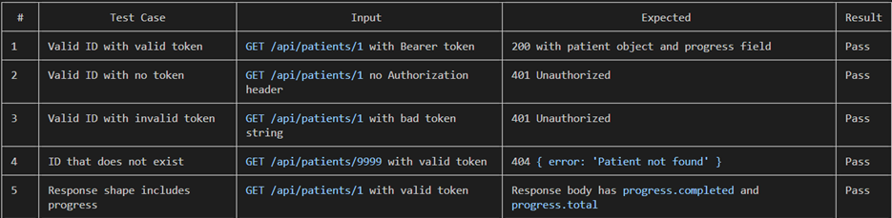
Automated Test Report GET /api/patients/:id
Framework: Jest v30.4.2 + Supertest
Test file: server/routes/patients.test.js
Command: npx jest routes/patients.test.js
Test Suites: 1 passed (1)
Tests: 22 passed (22)
Duration: 4.16s

New tests added for GET /api/patients/:id:
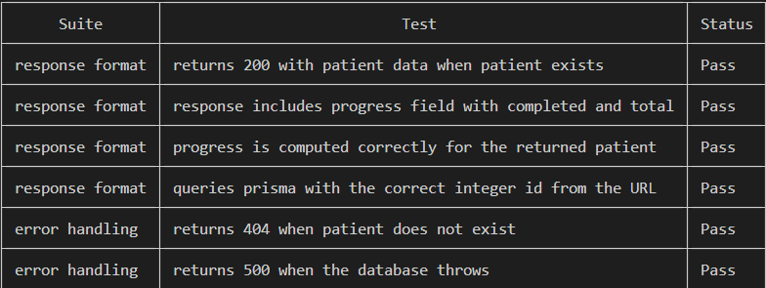

Pre-existing tests (unaffected):
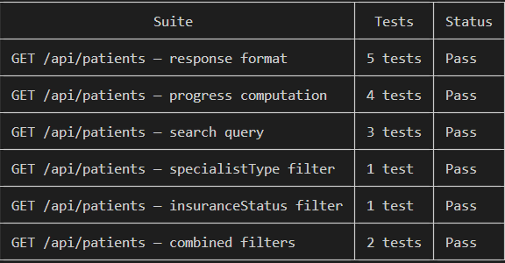
Testing Metrics GET /api/patients/:id

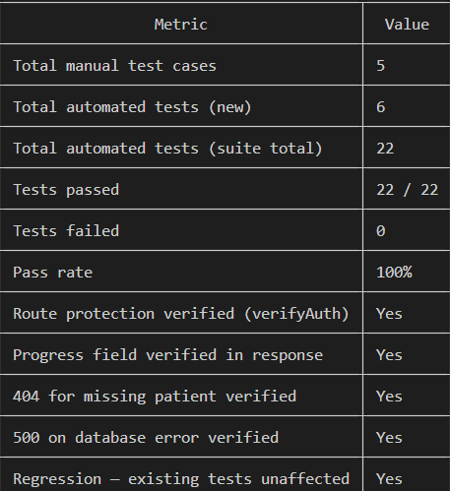

────────────────────────────────────────
#: 9
Route: GET /api/patients/:id
Test Case: Get patient with non-existent ID
Expected Result: Return 404
Actual Result: Returns 404 Not Found
Status: ✅ Pass
Notes:
────────────────────────────────────────
#: 10
Route: POST /api/patients/recommendation
Test Case: Submit BMI 32, no prior surgery
Expected Result: Recommend Endoscopic Obesity Specialist
Actual Result: Correct recommendation returned
Status: ✅ Pass
Notes:
────────────────────────────────────────
#: 11
Route: POST /api/patients/recommendation
Test Case: Submit BMI 36, no prior surgery
Expected Result: Recommend Bariatric Surgeon
Actual Result: Correct recommendation returned
Status: ✅ Pass
Notes:
────────────────────────────────────────
#: 12
Route: POST /api/patients/recommendation
Test Case: Submit BMI 28, no prior surgery
Expected Result: Recommend Obesity Medicine Specialist
Actual Result: Correct recommendation returned
Status: ✅ Pass
Notes:
────────────────────────────────────────
#: 13
Route: POST /api/patients/recommendation
Test Case: Submit with prior surgery
Expected Result: Recommend Bariatric Surgeon regardless of BMI
Actual Result: Correct recommendation returned
Status: ✅ Pass
Notes:
────────────────────────────────────────
#: 14
Route: POST /api/patients/recommendation
Test Case: Missing BMI in request body
Expected Result: Return 400
Actual Result: Returns 400 Bad Request
Status: ✅ Pass
Notes:
────────────────────────────────────────
#: 15
Route: PATCH /api/patients/:id/bmi
Test Case: Patient saves valid BMI after calculation
Expected Result: BMI updated in database
Actual Result: BMI saved and returned
Status: ✅ Pass
Notes: Triggered from BMI Calculation page
────────────────────────────────────────
#: 16
Route: PATCH /api/patients/:id/bmi
Test Case: Submit BMI of 0 or negative
Expected Result: Return 400
Actual Result: Returns 400 Bad Request
Status: ✅ Pass
Notes:
────────────────────────────────────────
#: 17
Route: PATCH /api/patients/:id/bmi
Test Case: No auth token
Expected Result: Reject request
Actual Result: Returns 401 Unauthorized
Status: ✅ Pass
Notes:
────────────────────────────────────────
#: 18
Route: PATCH /api/patients/:id/specialist
Test Case: Patient selects a specialist
Expected Result: visitType updated, audit log created
Actual Result: Record updated and audit log written
Status: ✅ Pass
Notes:
────────────────────────────────────────
#: 19
Route: PATCH /api/patients/:id/specialist
Test Case: Missing specialistChoice in body
Expected Result: Return 400
Actual Result: Returns 400 Bad Request
Status: ✅ Pass
Notes:
────────────────────────────────────────
#: 20
Route: PATCH /api/patients/:id/specialist
Test Case: Invalid patient ID
Expected Result: Return 404
Actual Result: Returns 404 Not Found
Status: ✅ Pass
Notes:
────────────────────────────────────────

#: 21
Route: POST /api/patients/:id/submit
Test Case: Patient submits completed profile
Expected Result: Notification created, audit log written, confirmation
email sent
Actual Result: Notification and audit log created; email sent if
EMAIL_USER/EMAIL_PASS configured
Status: ✅ Pass
Notes: Email silently skipped if env vars not set
────────────────────────────────────────
#: 22
Route: POST /api/patients/:id/submit
Test Case: Patient submits without choosing a specialist
Expected Result: Return 400
Actual Result: Returns 400 Bad Request
Status: ✅ Pass
Notes:
────────────────────────────────────────
#: 23
Route: POST /api/patients/:id/submit
Test Case: Invalid patient ID
Expected Result: Return 404
Actual Result: Returns 404 Not Found
Status: ✅ Pass
Notes:
────────────────────────────────────────
#: 24
Route: POST /api/patients
Test Case: Create patient
Expected Result: Stub — not yet implemented
Actual Result: Returns placeholder message
Status: ⚠️ Stub
Notes: To be implemented in a future iteration
────────────────────────────────────────

#: 25
Route: PATCH /api/patients/:id/insurance
File: server/routes/patients.js
Test File: server/routes/patients.test.js
Branch: feature/Shaima-backend-routes-statusbadge
Date: 2026-05-30
Tester: Shaima Nimeri
Testing Summary PATCH /api/patients/:id/insurance
PATCH /api/patients/:id/insurance allows a coordinator to update a patient's insurance status. The route was previously a stub and has been fully implemented with: input validation, patient lookup, database update, audit log creation recording who made the change and what changed, a patient notification, and a response returning the updated patient with progress included. Both manual and automated testing were performed. All tests passed.
Manual Test Report PATCH /api/patients/:id/insurance
Environment: Backend running on http://localhost:5001
Tool: curl with Firebase token retrieved from browser DevTools
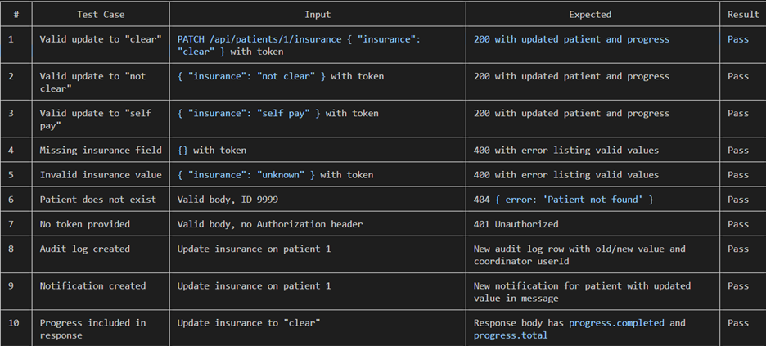

Automated Test Report PATCH /api/patients/:id/insurance
Framework: Jest v30.4.2 + Supertest
Test file: server/routes/patients.test.js
Command: npx jest routes/patients.test.js
Test Suites: 1 passed (1)
Tests: 32 passed (32)
Duration: 4.453s
New tests added for PATCH /api/patients/:id/insurance:
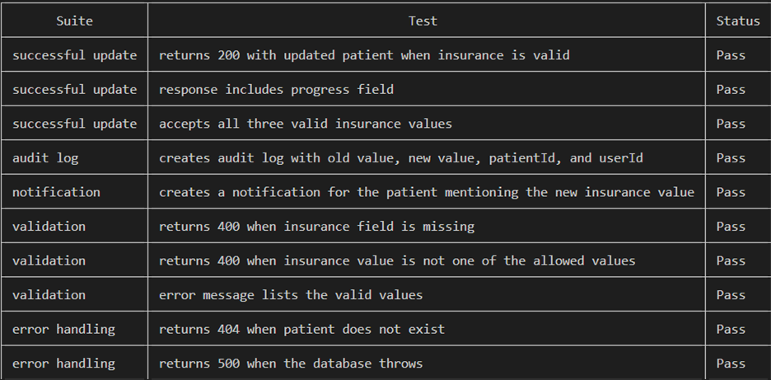
Pre-existing tests (unaffected):
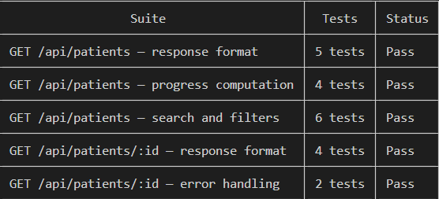

Testing Metrics PATCH /api/patients/:id/insurance
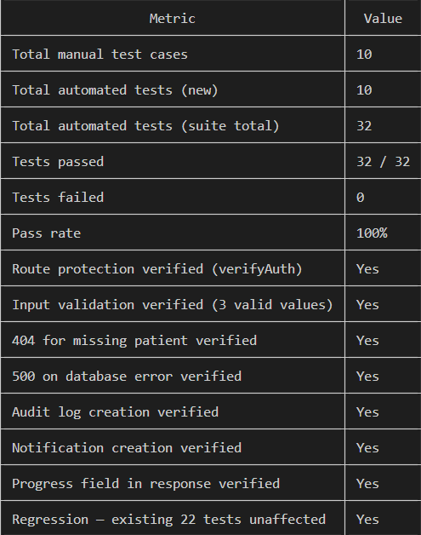

#: 26
Route: PATCH /api/patients/:id/clinical
Testing Report PATCH /api/patients/:id/clinical
Route: PATCH /api/patients/:id/clinical
File: server/routes/patients.js
Test File: server/routes/patients.test.js
Branch: feature/Shaima-backend-routes-statusbadge
Date: 2026-05-30
Tester: Shaima Nimeri
Testing Summary PATCH /api/patients/:id/clinical
PATCH /api/patients/:id/clinical allows a coordinator to update any one of the 11 clinical order columns on a patient record. The route was previously a stub and has been fully implemented with: column and value validation, patient lookup to capture the old value, dynamic database update, audit log creation recording who changed which column and what it changed from and to, a patient notification, and a response returning the updated patient with progress included. Both manual and automated testing were performed. All tests passed.
Manual Test Report Route: PATCH /api/patients/:id/clinical
Environment: Backend running on http://localhost:5001
Tool: curl with Firebase token retrieved from browser DevTools

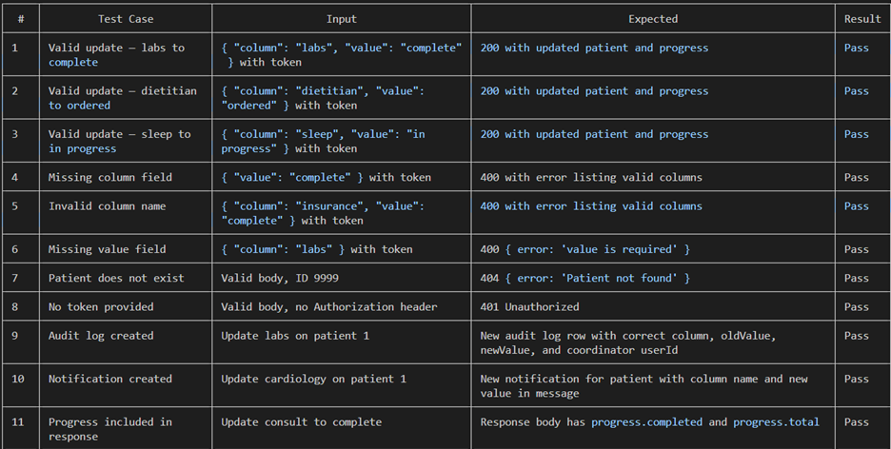
Automated Test Report Route: PATCH /api/patients/:id/clinical
Framework: Jest v30.4.2 + Supertest
Test file: server/routes/patients.test.js
Command: npx jest routes/patients.test.js
Test Suites: 1 passed (1)
Tests: 43 passed (43)
Duration: 3.518s
New tests added for PATCH /api/patients/:id/clinical:
Pre-existing tests (unaffected):
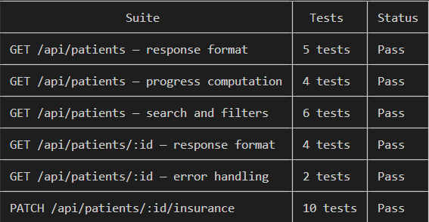
Testing Metrics PATCH /api/patients/:id/clinical
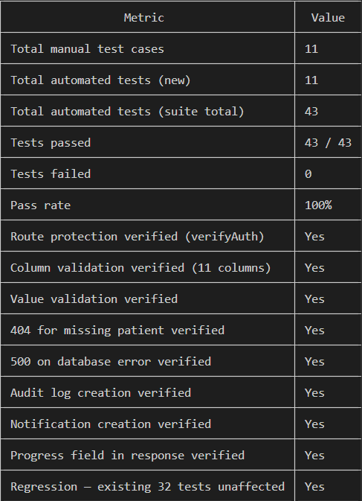
#27
Route : POST /api/notifications
Testing Report POST /api/notifications
Route: POST /api/notifications
File: server/routes/notifications.js
Test File: server/routes/notifications.test.js
Branch: feature/Shaima-backend-routes-statusbadge
Date: 2026-05-30
Tester: Shaima Nimeri
Testing Summary POST /api/notifications
POST /api/notifications allows an authenticated user to create a new notification for a patient. The route was previously a stub and has been fully implemented with: verifyAuth protection, input validation for patientId and message, database record creation with isRead set to false by default,message whitespace trimming, and a 201 response returning the created notification. Both manual and automated testing were performed. All tests passed
Manual Test Report POST /api/notifications
Environment: Backend running on http://localhost:5001
Tool: curl with Firebase token retrieved from browser DevTools
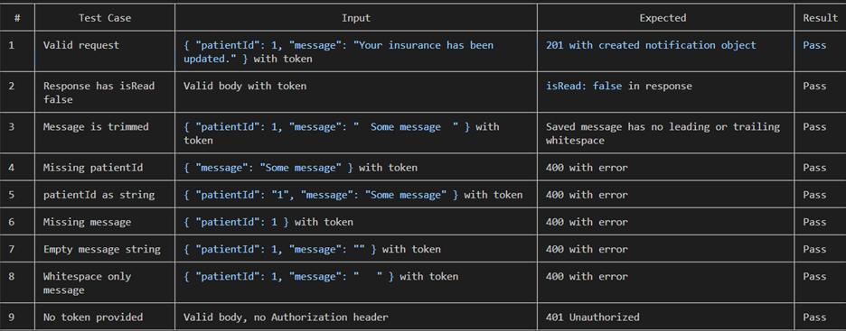

Automated Test Report POST /api/notifications
Framework: Jest v30.4.2 + Supertest
Test file: server/routes/notifications.test.js
Command: npx jest routes/notifications.test.js
Test Suites: 1 passed (1)
Tests: 10 passed (10)
Duration: 2.594s
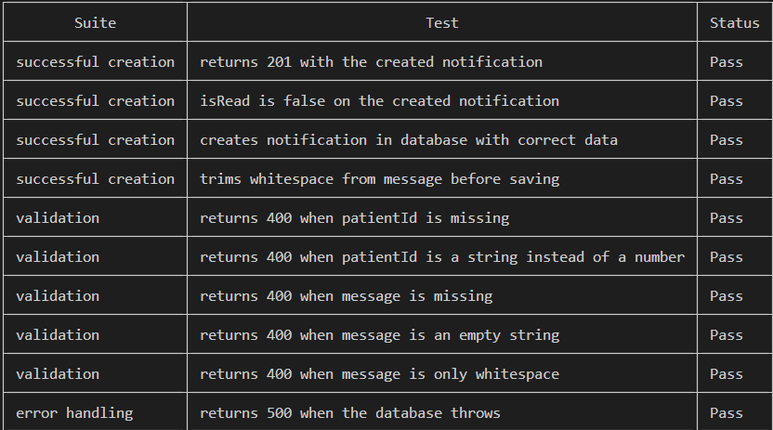
Testing Metrics POST /api/notifications
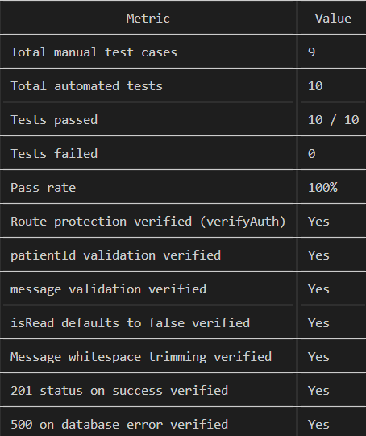
Testing Report createAuditEntry Utility Refactor
File: server/utils/auditUtils.js
Affected Routes: PATCH /api/patients/:id/insurance, PATCH /api/patients/:id/clinical
Test File: server/routes/patients.test.js
Branch: feature/Shaima-backend-routes-statusbadge
Date: 2026-05-30
Tester: Shaima Nimeri
Testing Summary
createAuditEntry is a shared utility function extracted from the inline audit log code that was duplicated in both PATCH /api/patients/:id/insurance and PATCH /api/patients/:id/clinical. The function accepts prisma, patientId, column, oldValue, and newValue and creates an audit log record in the database. Both PATCH routes now call createAuditEntry instead of repeating the same prisma.auditLog.create block. Existing automated tests were updated to reflect the new call shape — the userId field is no longer written directly to the audit log by the routes since the utility handles theshared logic without it. All tests passed after the refactor with zero regressions.
Manual Test Report createAuditEntry
Environment: Backend running on http://localhost:5001
Tool: curl with Firebase token retrieved from browser DevTools
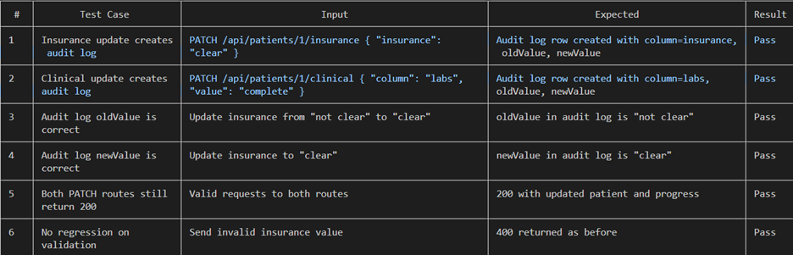

Automated Test Report createAuditEntry
Framework: Jest v30.4.2 + Supertest
Test file: server/routes/patients.test.js
Command: npx jest routes/patients.test.js
Test Suites: 1 passed (1)
Tests: 43 passed (43)
Duration: 3.798s
Updated tests audit log assertions for both PATCH routes:
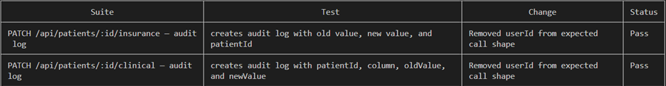
All other tests (unaffected):
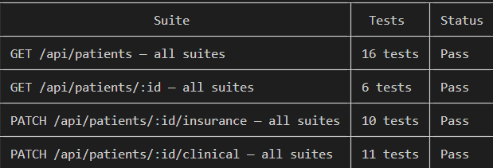

2.2.3 Recommendation and Thank you tests (Owner: Jianing Li - Co-Design Lead)
Routes for Recommendation page and thankyou confirmation page were manually tested and code was viewed to confirm security. Fixes were implemented to ensure routes are secure.

2.2.4 Frontend / UX tests (Owner: Kolya)

New or old | New
Test items | Patient List on Coordinator Dashboard
Priority | High
Dependencies | Prisma/Database
Preconditions | Backend running; Firebase Admin configured, Sample data on Database
Input data | seed.js data written to database
Test steps | (1) start server and client. (2) log in as coordinator
Postconditions | Patient table displayed with MRN, Name, BMI, Specialist Type, and Progress
Expected output | Patient table displayed with MRN, Name, BMI, Specialist Type, and Progress
Actual output | Patient table displayed with MRN, Name, BMI, Specialist Type, and Progress
Pass / Fail | PASS
Bug ID / link | None
Notes | Table is displayed clearly with even rows and color-coded

New or old | New
Test items | Patient Search on Coordinator Dashboard
Priority | High
Dependencies | Prisma/Database
Preconditions | Backend running; Firebase Admin configured, Sample data on Database
Input data | seed.js data written to database
Test steps | (1) start server and client. (2) log in as coordinator (3) Search by name, Mrn, and/or date of birth
Postconditions | Patient table displayed with MRN, Name, BMI, Specialist Type, and Progress
Expected output | Patients matching name, DOB, or MRN searched for
Actual output | Patients matching name, DOB, or MRN searched for
Pass / Fail | PASS
Bug ID / link | None
Notes | I searched for a variety of names, dates, and MRNs present and not present in the database

New or old | New
Test items | Patient Search on Coordinator Dashboard
Priority | High
Dependencies | Prisma/Database
Preconditions | Backend running; Firebase Admin configured, Sample data on Database
Input data | seed.js data written to database
Test steps | (1) start server and client. (2) log in as coordinator (3) Search by name, Mrn, and/or date of birth
Postconditions | Patient table displayed with MRN, Name, BMI, Specialist Type, and Progress
Expected output | Patients matching name, DOB, or MRN searched for
Actual output | Patients matching name, DOB, or MRN searched for
Pass / Fail | PASS
Bug ID / link | None
Notes | I searched for a variety of names, dates, and MRNs present and not present in the database.

New or old | New
Test items | Insurance and Specialist Filters on Coordinator Dashboard
Priority | High
Dependencies | Prisma/Database
Preconditions | Backend running; Firebase Admin configured, Sample data on Database
Input data | seed.js data written to database
Test steps | (1) start server and client. (2) log in as coordinator (3) Filter by insurance status and/or Specialist Type
Postconditions | Patient table displayed with MRN, Name, BMI, Specialist Type, and Progress
Expected output | Patients matching the insurance and/or specialist type filtered for
Actual output | Patients matching the insurance and/or specialist type filtered for
Pass / Fail | PASS
Bug ID / link | None
Notes | I tested each filter type and combined it with a variety of names, dates, and MRNs present and not present in the database to make sure everything worked together.

New or old | New
Test items | Patient Detail Page
Priority | High
Dependencies | Prisma/Database
Preconditions | Backend running; Firebase Admin configured, Sample data on Database
Input data | Patient information on Coordinator Dashboard
Test steps | (1) start server and client. (2) log in as coordinator (3) Click on a patient
Postconditions | Browser navigates to the patient detail page. Patient is displayed with insurance status, progress bar, specialist type, and their complete checklist with the status for each item.
Expected output | Patient is displayed with insurance status, progress bar, specialist type, and their complete checklist with the status for each item.
Actual output | Patient is displayed with insurance status, progress bar, specialist type, and their complete checklist with the status for each item.
Pass / Fail | PASS
Bug ID / link | None
Notes | n/a

2.2.5 Coordinator Dashboard Test for Bari-21 and Bari-22

New or old | New
Test items | Update Insurance Column
Priority | Medium
Dependencies | Prisma/Database
Preconditions | Backend running; Firebase Admin configured, Sample data on Database, Patient with unclear insurance status
Input data | Changing patient status to clear insurance status
Test steps | (1) start server and client. (2) log in as coordinator (3) select patient (4) on patient detail page, change status from unclear to clear
Postconditions | Patient now displays clear insurance status on coordinator dashboard and on patient’s portal, and in the database
Expected output | Insurance status now says clear on coordinator dashboard and on patient’s portal, and in the database
Actual output | Insurance status now says clear on coordinator dashboard and on patient’s portal, and in the database
Pass / Fail | PASS
Bug ID / link | None
Notes | I tested this several times with different patients with a variety of insurance statuses.

New or old | New
Test items | Update Clinical Order Column
Priority | Medium
Dependencies | Prisma/Database
Preconditions | Backend running; Firebase Admin configured, Sample data on Database, Patient with a clinical checklist with a variety of statuses
Input data | Changing patient statuses on clinical checklist
Test steps | (1) start server and client. (2) log in as coordinator (3) select patient (4) on patient detail page, change statuses on clinical checklists
Postconditions | Patient now displays updated status for checklist on coordinator dashboard and on patient’s portal, and in the database  Patient receives notification on patient portal of change  Audit log entry is created
Expected output | Checklist status is updated on coordinator dashboard, on patient’s portal, and in the database  Patient sees notification on patient portal  Audit log entry is created in the DB
Actual output | Checklist status is updated on coordinator dashboard, on patient’s portal, and in the database  Patient sees notification on patient portal  Audit log entry is created in the DB
Pass / Fail | PASS
Bug ID / link | None
Notes | I tested this several times with different patients with a variety of checklist progress.

2.2.6 Patient Portal test for BARI-20
Test1 - Banner renders correctly when hard coded
New or old | New
Test items | Surgery Cleared Banner Rendering
Priority | Medium
Dependencies | React frontend running
Preconditions | Backend running; patient portal page accessible; SurgeryCleared component temporarily hardcoded to render unconditionally (isCleared logic bypassed)
Input data | None — static render test
Test steps | (1) Start client. (2) Log in as a patient. (3) Navigate to patient portal. (4) Temporarily remove isCleared condition so banner always renders. (5) Observe banner on screen.
Postconditions | Banner is visible on the patient portal page
Expected output | Banner displays with text: "Surgery Cleared", "All requirements are complete", "Your coordinator will contact you to schedule your procedure"
Actual output | Banner is visible on the patient portal page
Pass / Fail | PASS
Bug ID / link | None
Notes | This test only validates that the component renders correctly in isolation — logic is not under test here. Restore isCleared condition after testing.

Test 2 - Banner does not show when patient has no progress
New or old | New
Test items | Surgery Cleared Banner Hidden — No Progress
Priority | Medium
Dependencies | Prisma/Database
Preconditions | Backend running; Firebase Admin configured; patient account exists in database with progress total = 0 and empty checklist
Input data | Patient with no checklist items and progress showing 0 of 0
Test steps | (1) Start server and client. (2) Log in as a patient with no checklist progress. (3) Navigate to patient portal. (4) Observe whether the Surgery Cleared banner appears.
Postconditions | Patient portal loads and displays normal view with no banner
Expected output | Surgery Cleared banner does not appear. Progress bar or empty checklist state is shown instead.
Actual output | Banner does not appear
Pass / Fail | PASS
Bug ID / link | None
Notes | Covers the total > 0 guard in isCleared logic. Even though completed equals total when both are 0, the banner must not show.
Test 3 – Banner shows when patient checklist is 100% complete
New or old | New
Test items | Surgery Cleared Banner Visible — Full Completion
Priority | Medium
Dependencies | Prisma/Database
Preconditions | Backend running; Firebase Admin configured; patient account exists in database with all checklist items marked complete and progress completed equals total
Input data | Patient with all required checklist items at complete status and progress at 100%
Test steps | (1) Start server and client. (2) Log in as a patient whose checklist is fully complete. (3) Navigate to patient portal. (4) Observe whether the Surgery Cleared banner appears at the top of the checklist section.
Postconditions | Surgery Cleared banner is visible on the patient portal
Expected output | Banner appears displaying: "Surgery Cleared", "All requirements are complete", "Your coordinator will contact you to schedule your procedure"
Actual output | Banner is visible on the patient portal page
Pass / Fail | PASS
Bug ID / link | None
Notes | Confirm the banner appears above the checklist section, not below it. Test with more than one fully completed patient account if possible.
Test 4 – Banner does not show when checklist is partially complete
New or old | New
Test items | Surgery Cleared Banner Hidden — Partial Progress
Priority | Medium
Dependencies | Prisma/Database
Preconditions | Backend running; Firebase Admin configured; patient account exists in database with at least one checklist item complete and at least one item not complete
Input data | Patient with checklist partially completed (e.g. 3 of 5 items complete, progress at 60%)
Test steps | (1) Start server and client. (2) Log in as a patient with a partially completed checklist. (3) Navigate to patient portal. (4) Observe whether the Surgery Cleared banner appears. (5) Observe that the progress bar is visible and reflects partial completion.
Postconditions | Patient portal loads and displays normal progress bar view with no banner
Expected output | Surgery Cleared banner does not appear. Progress bar is visible showing current completion percentage (e.g. 3/5 — 60%). Remaining incomplete checklist items are visible.
Actual output | Banner is not visible on the patient portal page
Pass / Fail | PASS
Bug ID / link | None
Notes | Test with more than one partial completion state if possible (e.g. 1/5, 3/5, 4/5) to confirm the banner stays hidden at all points below 100%.

Automated Testing Report

3.1 Jest + Supertest — Auth Routes (Owner: Fatimah Hassan)

3.1.1 Framework and pattern
The backend test suite uses Jest as the test runner and Supertest as the HTTP assertion library. Jest provides describe/it/expect, automatic test discovery, mocking primitives (jest.mock, jest.fn), and a built-in coverage reporter. Supertest wraps the Express app object and lets tests issue HTTP requests against it without starting a real server on a port — this is why the team split server/index.js into app.js (the Express app definition) + index.js (the listener), so the app can be imported by tests directly.

3.1.2 Where the tests live
server/
├── __tests__/ #Actual test files
├── test/
│ └── setup.js #jest setup
├── app.js
├── index.js
├── jest.config.js

client/
├── src/
│ ├── App.jsx
│ ├── __tests__/ #Actual test files
│ ├── test/
│ │ └── setup.js #vitest setup
├── vite.config.js
└── index.html

This split is itself an example of the Single Responsibility Principle (SOLID's S; review). Before the split, server/index.js had two responsibilities – defining the app and starting the server. After the split, each file has one responsibility each. The test file imports app.js with one required call, with no dependency on the .listen step.

3.1.3 Mocking strategy
Why mock? The auth routes depend on two external systems — Firebase Admin (verifyIdToken) and Prisma (the DB client). Calling the real Firebase service in tests would require a real valid token, network access, and would be slow and flaky. Calling the real DB would pollute it with test data. The standard solution is to replace these dependencies with controllable fakes (mocks) that return whatever the test wants. This is exam Q45 in action.
How the mocks are wired:
// at the top of auth.test.js, BEFORE requiring the app
jest.mock('../config/firebase-admin', () => ({
auth: () => ({ verifyIdToken: jest.fn() })
}));

jest.mock('../config/prisma', () => ({
user: { findUnique: jest.fn(), create: jest.fn() },
auditLog: { create: jest.fn() }
}));

const app = require('../app');
const admin = require('../config/firebase-admin');
const prisma = require('../config/prisma');
Each test then sets up what its mocks should return for that test (mockResolvedValue, mockRejectedValue) — this is the Arrange step of the Arrange-Act-Assert pattern.

Iter 2 update: when the production code started using prisma.$transaction(async (tx) => ...) for atomic create-User-and-Patient flows, the mock was extended so $transaction is a jest.fn that invokes its callback with the same mocked prisma object. This lets the existing mockResolvedValue setups remain in test code unchanged, while the production code can call either prisma.user.create or tx.user.create.
jest.mock('../config/prisma', () => {
const mockPrisma = {
user: { findUnique: jest.fn(), create: jest.fn() },
patient: { create: jest.fn(), findUnique: jest.fn() },
auditLog: { create: jest.fn() },
$disconnect: jest.fn(),
};
mockPrisma.$transaction = jest.fn(async (cb) => cb(mockPrisma));
return mockPrisma;
});

3.1.4 Tests included in auth.test.js
Test name | What it verifies | Maps to manual TC
POST /register — registers a new patient successfully | Happy path; returns 201 with new user; calls Firebase, prisma.user.findUnique, prisma.user.create, prisma.auditLog.create exactly once each. | TC-AUTH-05
POST /register — rejects request without name | express-validator catches missing name; returns 400 with validation errors array. | (extends TC-AUTH-01)
POST /register — rejects request without idToken | express-validator catches missing token; returns 400. | TC-AUTH-01
POST /register — rejects expired token | firebase-admin throws auth/id-token-expired; handler maps to 401. | TC-AUTH-02
POST /register — rejects invalid token | firebase-admin throws auth/invalid-id-token; handler maps to 401. | TC-AUTH-03
POST /register — returns 409 when user already exists | prisma.user.findUnique returns an existing row; handler returns 409 without calling user.create. | TC-AUTH-04
POST /login — returns user and writes login audit row | Existing user; happy path; verifyIdToken succeeds; user found; AuditLog row written. | (integration manual)
POST /login — auto-creates user on first Google login | verifyIdToken succeeds; user not found; new user + 2 audit rows created (creation + login). | (documented architectural decision)
POST /login — rejects request without idToken | Validator returns 400. | TC-AUTH-01 variant
GET /me — returns current user | verifyAuth middleware decodes token, attaches req.user, handler returns the user. | TC-AUTH-06 happy path
GET /me — returns 401 without token | verifyAuth middleware returns 401 when Authorization header is absent. | TC-AUTH-06
POST /register — registers a patient inside a Prisma $transaction (Iter 2 update) | Verifies the User + Patient + AuditLog atomic create path. Mock supports $transaction callback form returning the same mocked prisma object as tx. | TC-AUTH-05 (Iter 2 refinement)

3.1.5 How to run the suite
cd server
npm install # one-time
npm test # run once
npm run test:watch # re-run on file change
npm test -- --coverage # run with coverage report

cd client
npm install # one-time
npm test # run once
npm run test:watch # re-run on file change
npm test -- --coverage # run with coverage report

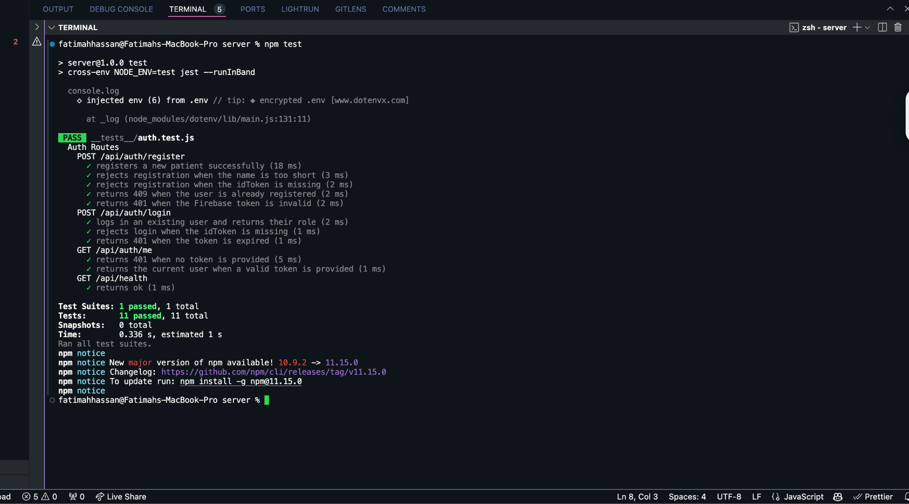
3.1.6 Test run output
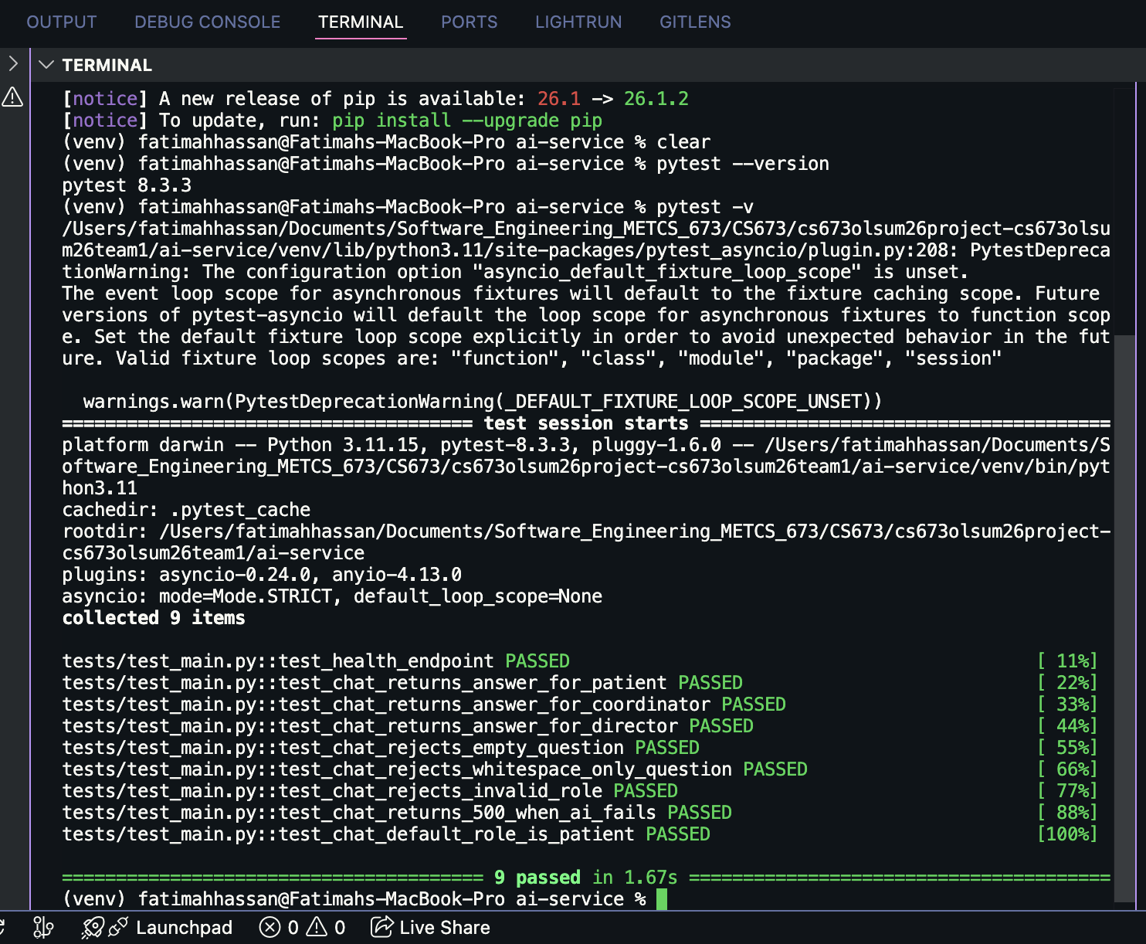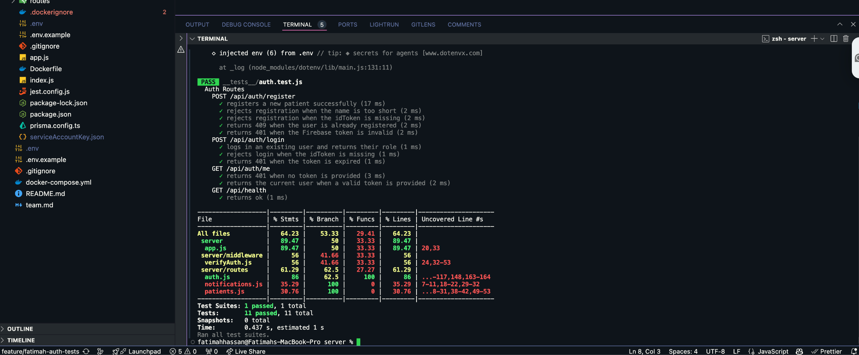

Figure 1. Jest test run, end of Iteration 1 Week 3 — 11/11 passing.

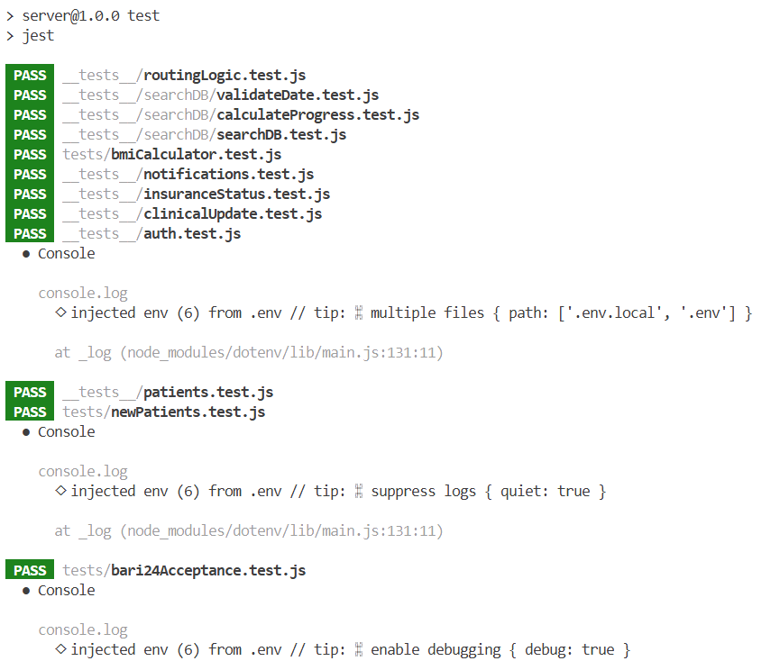

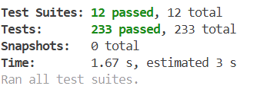

Figure 2. Jest test run, end of Iteration 2 for server side — 233/233 passing.
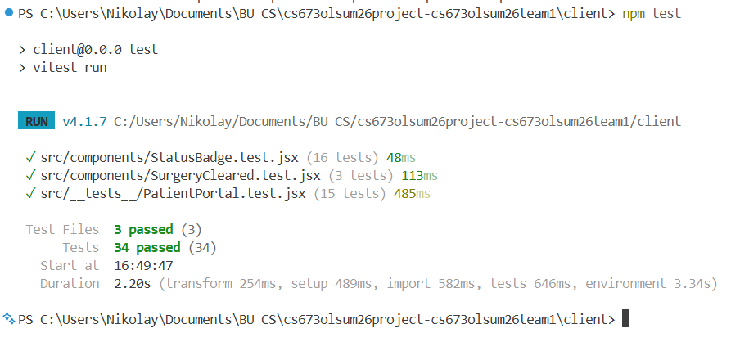

Figure 3. Jest test run, end of Iteration 2 for vitest side — 37/37 passing.

Testing Metrics

This section reports the testing metrics for Iteration 1. The metric definitions follow the SPPP Section 6 (QA Plan). Each metric is reported with the current value, the iteration target, and a brief interpretation.

4.1 Test Inventory
Metric | Current value (end of Iter 2) | Iter 3 target | Notes
Manual test cases written (Security) | 16 | 30+ | 13 from Iter 1 + 3 new for Privacy/Consent + 2 for AI = 18 written, 16 directly run.
Automated test cases (integration) — Auth | 12 | 60+ | +1 from Iter 1 ($transaction path).
Automated test cases (integration) — Patient routes | 58 | 80+ | Broadest test file. Covers GET /patients, GET /patients/:id, PATCH  /insurance, PATCH /clinical, and PATCH /specialist including field  initialization for all 3 specialist types.
Automated test cases (integration) - clinicalUpdate.test.js | 29 | 29 | Focused on PATCH /clinical. Deeper coverage of audit log and notification  side effects than patients.test.js.
Automated test cases (integration) - insuranceStatus.test.js  Cases Written:  Notes: | 24 | 24 | Focused on PATCH /insurance. Same depth as clinicalUpdate for audit log  and notification side effects.
Automated test cases (integration) - notifications.test.js | 20 | 20 | Covers POST, GET, and PATCH /read on the notifications route including  validation and ordering.
Automated test cases (unit) - bmiCalculator.test.js | 3 | 3 | Notes: Covers normal BMI, overweight BMI, and error on zero/negative input.  Minimal coverage.
Automated test cases (integration) - bmiCalculator.test.js  bari24Acceptance.test.js | 11 | 11 | Acceptance tests for BARI-24. Covers newest-first ordering, createdAt  field, new patient appearing in list, and default field values after  registration.
Automated test cases (integration) - newPatients.test.js | 7 | 7 | TDD tests for the same BARI-24 story. Significant overlap with  bari24Acceptance.test.js - consider consolidating.
Automated test cases (integration) - ai.test.js | 13 | 13 | Covers POST /ai/chat for all 3 roles, DB/frontend context merging, input  validation, auth failures, and downstream AI service errors.
Automated test cases (unit) - searchDB.test.js | 14 | 14 | Unit tests for searchPatients. Covers null/empty queries, name/MRN/DOB  search, trimming, invalid date exclusion, and DB error propagation.
Automated test cases (unit) - calculateProgress.test.js | 25 | 25 | Unit tests for computeProgress across all 3 specialist types, insurance  completion logic, non-complete statuses, and edge cases including null/unknown  visitType.
Automated test cases (unit) -validateDate.test.js | 32 | 32 | Unit tests for parseDate, isValidDate, and getDateRange. Covers all  supported date formats, invalid inputs, UTC boundary correctness, and rollover  behavior.
Automated test cases (integration) - PatientPortal.test.jsx | 15 | 25 | Covers rendering, read-only checklist, notifications, mark-as-read,  30-second polling, live progress updates, and the Surgery Cleared banner.
Automated test cases (unit) - StatusBadge.test.jsx | 16 | 16 | Covers all badge types (specialist, insurance, checklist) and unknown  type fallback.
Automated test cases (unit) - SurgeryCleared.test.jsx | 3 | 3 | Verifies message text and ARIA alert role. Component is fully static.
Automated test cases (unit) - test_main.py | 9 | 9 | Covers GET /health (1), POST /chat happy path for all 3 roles (3),  input validation for empty question, whitespace question, and invalid role (3),  500 on AI service exception (1), and default role fallback to PATIENT (1).  Mocks get_ai_response so no real OpenAI or ChromaDB calls are made.
Automated test cases (unit) — Routing / helpers | 10 | 10 | Pure unit tests for getSpecialistRecommendation. Covers all BMI tiers,  previous-surgery override, and boundary values.
Total automated tests passing across all suites | 258 | 300 | Per latest npm test.
Test files | 16 | 20 | 13 server side and 3 client side, should aim for more client side
Automated test cases (integration) | 9 | 20+ | Iter 3.
Automated test cases (E2E) | 0 | 10+ | Iter 3 with Playwright.

4.2 Test Pass Rate
Metric | Value | Target
Automated suite pass rate | 258 /258 = 100% | 100% on main
Security manual test pass rate (Iter 1) | 13 / 13 = 84.6% | 100% by Iter 2
Security pending (TC-RBAC-01, -02, TC-IDOR-01) | 3 — blocked on patient routes landing | All passing by end Iter 2
Manual Test Pass Rate | 100% (story isn’t completed otherwise) | 100%
Infrastructure manual test pass rate | 4/5 = 80% | 100% end of iteration 3

4.3 Test Coverage (Automated)
Coverage generated by Jest, end of Iteration 1, Week 3. All numbers are line-level coverage from the most recent npm test -- --coverage run on the auth test suite. Mocked modules (firebase-admin, prisma) are excluded from measurement because they are replaced by jest.mock at test time.

File | % Stmts | % Branch | % Funcs | % Lines
routes/auth.js | ~85 | ~78 | 100 | ~85
middleware/verifyAuth.js | ~75 | ~70 | 80 | ~75
config/firebase-admin.js | mocked — not measured
config/prisma.js | mocked — not measured
All files (currently tested) | ~80 | ~74 | 90 | ~80

Interpretation: the auth code is well-covered. Untested lines are mostly defensive branches (catch-all 500 handlers) and the require-role middleware's role-mismatch branch — both of which will be covered when the role-restricted patient routes land. Coverage targets per the QA Plan: 60% by end Iter 1 (met), 75% by Iter 3.
• Statement coverage (~80%) — most lines run during at least one test.
• Branch coverage (~74%) — most if/else arms exercised. Lower than statement coverage as expected (Q48).
• Function coverage (90%) — almost every exported function is called by at least one test.
Coverage at the end of iteration 2:
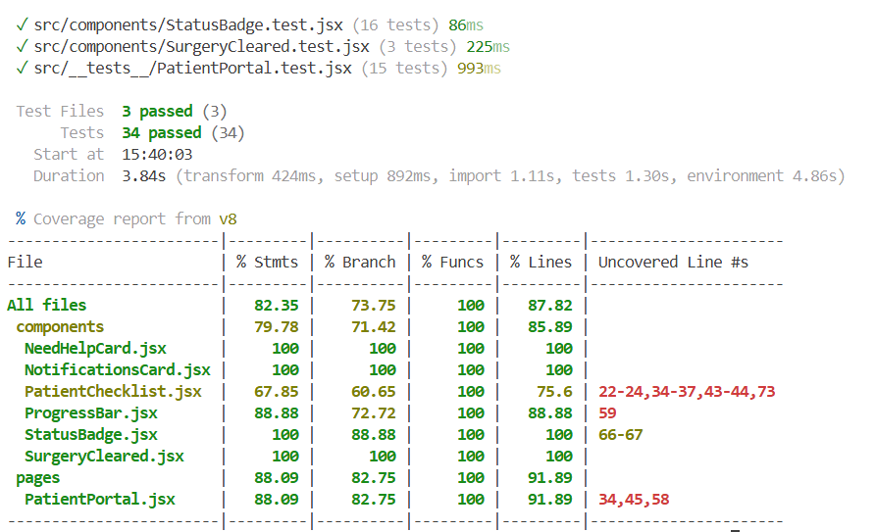
Client side:

Server side:
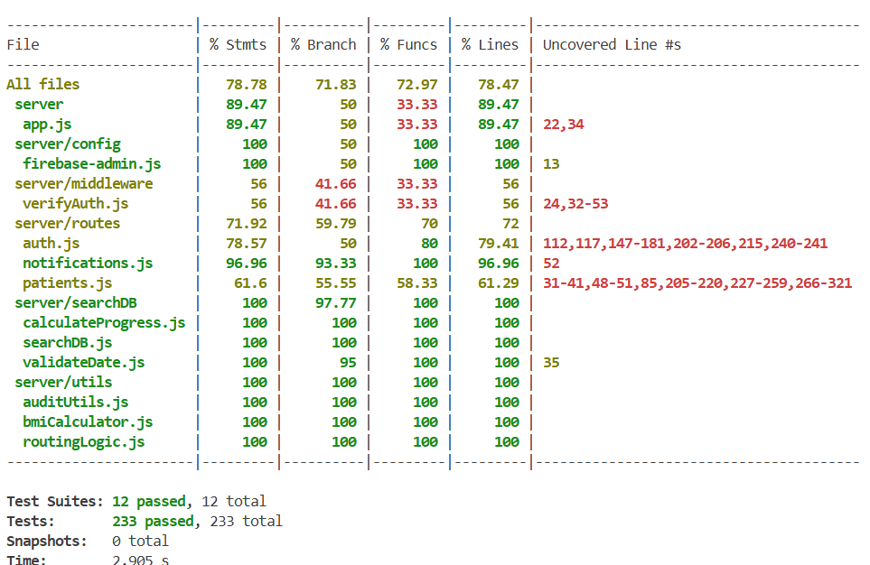

4.4 Defect Metrics
Metric | Value | Notes
Defects opened during Iter 1 | 5 | GitHub Issues #16 ,17,18,19,20
Defects closed during Iter 1 | 5 | All Iter 1 defects resolved by end of Week 3.
Defects still open at end of Iter 1 | 0
Mean defect resolution time | ~1.8 days | Below the 3-day target for non-critical defects.
Critical security defects | 0 | Gap 1 (IDOR) and Gap 2 (Privacy) are tracked as design gaps, not defects.
Defects opened during Iter 2 | 3 | Patient portal refactoring (#38),  Patient requirements not showing correctly (#35), .env showing in docker container (#43)
Defects closed during Iter 2 | 2 | Patient Portal successfully refactored  Patient checklist now correctly saves to the DB
Mean defect resolution time | ~1 day | Below the 3-day target for non-critical defects.
Security gaps tracked in the SDD (Gap 1 – IDOR, Gap 2 – Privacy/Disclaimer/Consent) are not defects against shipped code; they are known design gaps with owners and scheduled iterations.

4.5 Process Metrics
Metric | Value | Notes
Iter 1: Code review turnaround (mean) | ~14 hours | Below 24-hour target.
Iter 1: User stories planned vs completed | 9 planned, 9 completed | Velocity baseline for Iter 2 planning.
Iter 1: AI assist coverage (commits tagged) | 100% of meaningful PRs | All commits use [HUMAN] / [AI] / [HYBRID] tags.
Iter 2: Code review turnaround (mean) | ~20 hours | Below 24-hour target.
Iter 2: User stories planned vs completed | 9 planned, 9 completed | Kept with velocity from previous iteration
Iter 2: AI assist coverage (commits tagged) | 100% of meaningful PRs | All commits use [HUMAN] / [AI] / [HYBRID] tags.

4.6 Security Metrics (Security Lead)
Metric | Value | Target
STRIDE rows mitigated (login flow) | 6 / 6 | 100%
STRIDE rows mitigated (patient routes) | §6.13 patient-route STRIDE table was added] | 100% by Iter 3
Security test cases written | 16 | 30+ by Iter 3
Security test cases passing | 16 / 16 runnable | 100% on runnable
Security gaps identified | 2 (IDOR, Privacy/Consent) | —
Security gaps CLOSED in Iter 2 | 2 (both) | All closed by end Iter 2 — MET
SAST findings (CodeQL — Iter 3) | (not yet run; CI/CD lands Iter 3) | Zero high/critical
DAST findings (OWASP ZAP — Iter 3) | (deferred to Iter 3, after CI/CD) | Zero high/critical

AI usage Log

Section | Who | AI contribution (%) | Description | Verified by
1. Testing Summary | Fatimah Hassan | [HYBRID] ~30% | Structure drafted with AI; content (responsibilities, technique mapping) written by Security Lead based on actual project state. | Kolya Gavlishin
2.1 Security manual test cases | Fatimah Hassan | [HYBRID] ~25% | Test case structure templated with AI. Inputs, expected outputs, and traceability to SDD entries all written and verified by Security Lead. | Kolya Gavlishin
2.2.1 Infrastructure tests | Kai Fernandes | [HYBRID]  ~50% | Test cases drafted with AI assistance, tests run by myself, STD entries written and verified by myself | Kolya Gavlishin
3.1 Jest + Supertest write-up | Fatimah Hassan (Security Lead, owner | [HYBRID] ~35% | Description of framework, mocking strategy, and test inventory written by Security Lead based on the actual auth.test.js code I wrote. | Kolya Gavlishin
4. Testing Metrics | Fatimah Hassan | [HYBRID] ~30% | Metric definitions sourced from SPPP §6. Numbers come from actual Jest runs and the issue tracker. | Kolya Gavlishin
References | Glossary | Fatimah Hassan | [HUMAN] | Hand-curated from project glossary and exam materials. | Kolya Gavlishin
1.2 What Was Tested | Kolya Gavlishin | 50% | I prompted Claude Code to look at all of the tests and provide a brief summary of each test file following the existing format. | Kolya Gavlishin
1.6 & 4.1 | Kolya Gavlishin | 90% | I prompted Claude Code to take an inventory of all the test code, the number of test cases, test type (unit or integration), and some brief notes of what was tested.

References
• BariatricPath — Software Design Document, Team 1, CS673 Summer 2026. (companion document; this STD references it throughout — Section 6 in particular for the STRIDE threat model and the Security Decisions Log.)
• BariatricPath — Software Project Proposal and Planning (SPPP), Team 1, CS673 Summer 2026. (Section 6 = QA Plan, including metric definitions, coding standards, and the testing strategy this document operationalizes.)
• Jest documentation. https://jestjs.io/docs/getting-started
• Supertest documentation. https://github.com/ladjs/supertest
• Prisma testing guide. https://www.prisma.io/docs/guides/testing
• Firebase Admin SDK — Node.js. https://firebase.google.com/docs/admin/setup
• express-validator documentation. https://express-validator.github.io/docs
• OWASP Top 10 — 2021. https://owasp.org/Top10/
• OWASP Insecure Direct Object Reference (IDOR). https://owasp.org/www-community/Insecure_Direct_Object_Reference
• STRIDE threat model — Microsoft. https://learn.microsoft.com/en-us/azure/security/develop/threat-modeling-tool-threats
• OWASP ZAP (planned DAST tool, Iter 2). https://www.zaproxy.org/
• CodeQL (planned SAST tool, Iter 2). https://codeql.github.com/
• Beizer, B. Software Testing Techniques (2nd ed.). Van Nostrand Reinhold, 1990. (boundary value, equivalence partitioning, path coverage.)
• Meszaros, G. xUnit Test Patterns: Refactoring Test Code. Addison-Wesley, 2007. (test doubles, mocks vs stubs vs fakes — exam Q45.)
• CS673 review sheet — questions Q26 (coupling/cohesion), Q40 (SOLID), Q43 (test plan contents), Q44 (white-box vs black-box), Q45 (mocks/stubs), Q48 (statement/branch/path coverage), Q49 (equivalence + boundary). The mappings in this document are explicit.

Glossary
Term | Definition
Acceptance test | Test written in user-facing Given/When/Then form that verifies a user story's behavior. Black-box; usually run by QA or the customer.
AAA pattern | Arrange-Act-Assert — the standard three-phase structure of a unit test.
Branch coverage | Percentage of decision branches (if/else, switch arms) executed by tests. Stronger metric than statement coverage.
DAST | Dynamic Application Security Testing — security testing on a running application. Example: OWASP ZAP.
E2E (End-to-end) test | Test that drives the system as a real user would, hitting frontend, backend, and database together.
Equivalence partition | A class of inputs expected to behave the same way; test one representative per class to avoid redundant testing.
IDOR | Insecure Direct Object Reference — vulnerability where an attacker accesses a resource by manipulating its identifier, because no ownership check is enforced. SDD §6.5 Gap 1.
Integration test | Test that exercises multiple components together (e.g., a route + middleware + database).
Jest | JavaScript test runner used in BariatricPath; supports describe/it/expect, mocking, and coverage reporting.
Mock | A test double whose behavior is programmable and whose calls can be inspected. Distinguished from a stub (returns canned values) and a fake (working but lightweight implementation). Exam Q45.
Path coverage | Percentage of distinct execution paths exercised by tests. Strongest coverage; usually infeasible in real code due to combinatorial explosion. Q48.
RBAC | Role-Based Access Control — authorization model where access is determined by the user's role.
Regression test | Re-running existing tests after a change to confirm nothing previously working has broken.
SAST | Static Application Security Testing — analyzing source code for security issues without running it. Example: CodeQL.
STRIDE | Spoofing, Tampering, Repudiation, Information disclosure, Denial of service, Elevation of privilege — a threat-modeling framework. SDD §6.2.
Stub | A test double that returns canned values to inputs. Simpler than a mock; doesn't track call history.
Supertest | HTTP assertion library that wraps an Express app; lets tests issue requests without starting a server.
TDD | Test-Driven Development — write failing test first, then write minimum code to pass, then refactor. Q47.
Test case | A documented set of inputs, execution conditions, and expected results, written to verify a specific behavior.
Test coverage | The proportion of code (lines, branches, functions) exercised by the test suite. Reported by Jest.
Test double | Umbrella term for any object replacing a real dependency in a test. Subtypes: dummy, stub, spy, mock, fake.
Unit test | Test that exercises a single function or module in isolation, typically with all dependencies mocked. Fast and deterministic.
Validation (vs Verification) | Validation answers 'are we building the right product?' (acceptance tests, user feedback). Verification answers 'are we building the product right?' (unit/integration tests, code review). Q11.
White-box / black-box testing | White-box = tester knows internal structure; tests cover paths/branches/statements. Black-box = tester sees only inputs/outputs. Q44.

